Health literacy promotion in public schools of Kazakhstan

The degree of development of promoting health literacy in public schools

Ways of improving the promotion of health literacy

Madeniyetova Assem

Nazarbayev Intellecttual School 11 “A”

Word count: 4052

Introduction
339
HHS (Health and Human Services) has given to the term Health Literacy, which is considered vital in maintaining health, a definition “the degree to which individuals have the capacity to obtain, process, and understand basic health information needed to make appropriate health decisions.” (Healthy people n.d)
The reason why I came up with this topic is that health issues are ubiquitous in our lives and in many cases it is the repercussion of lack of specific knowledge in topic of health. For instance, the recent flasg of corona virus occurred and spread because people did not pursue basic rules of safety, because they were either not aware of their importance or of them at all. Analogical situations can be noticed among people with heart diseases, infections and other widely-spread illnesses. Since the school is the place where basics of natural sciences and physical education are taught and where teenagers spend most of their time, students of most distributed –public-schools were chosen. This research investigates the promotion of health literacy in public schools of Kazakhstan, scrutinizing the approaches that are already implemented and offering new measures that will probably improve this issue.

I am biased that public schools provide little information about health is restricted in frames of chemistry and biology lessons, and school doctors do not hold meetings explaining the importance of healthy lifestyle. I also have to avoid the one side opinion that present measures are ineffective, since I have not investigated how useful they are. These considerations are based on stereotypes, thus are accepted as bias, and can lead to subjective conclusion.
This research appears to have considerable benefits. Provided that schools adopt the measures that will be offered, first who will benefit is students. In fact, it is more long-term advantage, since gained knowledge will be reliable in any time, students will be ready for future life. Generally, the main advantage is that people will become more informed in what to eat, how to select a treatment and avoid (or prevent) diseases, yet only in case the suggested methods will be implemented.

Context 432

The Institute of Medicine (IOM) has defined the term “heath literacy” as the "the degree to which individuals have the capacity to obtain, process, and understand basic health information and services needed to make appropriate health decisions." (Healthy People, 2020) .
Undoubtadly, health issues relate to the whole world, since we are now living in a globalized world, full of international economical connections, travel, and commerce. “Since the 1970s, newly emerging diseases have been identified at the unprecedented rate of one or more per year.” (World Health report, 2007) . Generally, those people who lack health literacy: (Healthy People, 2020)

- Are more likely to choose wrong medicines, thus deteriorating the hurdle
- Have worse health status and use less approaches to prevent diseases.
- Are more likely to be hospitalized at late stages of diseases
- Appear to increase the money expenditure on medicine

The problem of low health literacy is topical world wide. Adult Literacy and Life skill Survey held in 2006 showed that only 41% of citizens in the age of 15-74 showed adequate and above levels of health literacy. In countries of England, USA, and Canada which are known for effective health care system, the low health literacy rates range from 20-40%
Low health literacy can bring about troubles in functioning in health care system, decreased health rates (e.g Australia 7-9), wrong approach of self-treatment and many others. (Healthy People, 2020)
There was held a research in Kazakhstan that obtained 1000 people from 5 different cities. It shows that 33% of all respondents cannot manage self- treatment and 56% of students showed low and unsatisfactory rates. Bakhyt Tumenova, a member of health organization and coordination of Kazakhstan states that health education should be integrated from the childhood in partnership of parents and schools.(Matricakz, 2020)

From economical lens, the government states it is economically efficient to increase the HL(health literacy). Because of low HL, in 2002 the US 32 million dollars in addition to the initial allocation. (Nikolina Dukić, Andrea Arbula Blecich & Ljerka Cerović, 2013)
Besides saved money, they will profit from higher number of labor force.

From the social lens, from the perspectives of doctors and medical supporters it deteriorates the process of bonding. When person lacks information, it causes lack of trust, confidence and thus complicates the Doctor-Patient relationships. From the perspective of patient, inability to fully comprehend the speech of a doctor deteriorates the ability to be assured in the competence of the doctor. The HL was approved to be a factor of problems between doctors and patients. (Prim Care Companion CNS Disord, 2015)

Aims&Hypothesis 184

Research aim is to estimate the adequacy of promotion of health literacy at schools and suggest methods that would improve it.
The hypothesis:I predict that the adequacy of the promotion of HL in public schools of Kazakhstan is not sufficient and thus needs improvements, especially in organizing. As a student of a not public school, I have noticed many differences in the way students of my school and public schools get the health related information from different conversations with them. Student do not usually investigate and search the HL topic themselves, which means that their health competence depends on the way school provides this information. Since studies show low Hl, it is logical to predict that organizing process is not adequate.
The questions that will be considered are:
- Do schools promote students with relevant information(about diet, physical education, medical support, self-treatment)?
- How do students process and adopt the theory that refers to HL?
- What could be done to improve present measures, making them more effective on practice?
- What students and parents consider about the approaches schools use to promote health literacy?

Methods
810

The topic of the research is “The adequacy of promotion of health literacy in public schools of Kazakhstan”
While searching the issues around health literacy in our country, I have found a reasonable opinion of an admirable individual – Bakhyt Tumenova, doctor, health organizer- “It is necessary to start educating the population from childhood on the basis of partnership of health and education institutions with the participation of parents, and further on in enterprises and organizations within the framework of health care programs of working people”. Thus, the established research aims to estimate the adequacy of promotion of health literacy at schools and suggest methods that would improve it. To achieve this aim and answer relatable questions surrounding this topic, I have chosen next methods: Survey, Interview.

Survey
This method is a way of gathering information and data from a predefined group. This method was chosen because it allows obtaining high amount of respondents in a relatively short period of time, gathering mostly quantitative data (Guest, 2019).This is beneficial, because the wider the range of responses is, the more objective analysis is expected to be. From present researches on promotion of health literacy in Kazakhstan (both at schools and in general) very little information can be found. Apparently, there are some challenges of using this tool. Although the statistical data provided by survey is easy to systemize and analyze, numbers sometimes can be too categorical. (Qeryz, 2020) Also, respondents may be biased while answering to the questionnaire, especially in case of wrong formulation of the question and options.
The purpose of the survey is to identify how effectively schools teach healthy lifestyle and search methods for improvements. The population is students of public schools in the age of 12-19 (this was determined according to the average ability to respond to the questions consciously). Answers of students are compulsory, since they are the aimed subjects of the research For instance, students of 9th grade of school #44 in Oskemen may respond to the questionnaire. The survey includes categorizing, grading, open, and yes/no questions. Overall, it is expected to obtain the aspects of relevancy of the information regarding the health literacy at schools, possible improvements, and students’ attitudes.
The minimum number of the questionnaire responds is 50, which is as my teacher has said is a useful number for analyzing (when counting in %) and is accessible to reach by a student.
The questions are easy structured and do not demand a big amount of time.

Interview
The interview is a useful method of gathering quantitative data from valid roles, whose opinions are important for depth analysis and compromising the potential errors of survey. (Jamshed, 2014)Possible issues of using this tool are:
Parents were chosen to be engaged in the interview, since they are responsible for students’ health (according to the Kazakhstan code), and according to our context, should be invigorated in process of teaching health. The research aims to investigate parents’ view on efficiency of health literacy at schools of their children. Accordingly, I am interviewing specifically a representative of parents’ committee, since they are the “connecting bridge” between the school and parents. It is expected to get answers to the aspects of parents’ current engagement, their attitudes. 3 individuals will be interviewed, since schools in different regions may vary, which makes responds of one interviewee not sufficient. In order to avoid extra quantitative data and save time, more than 3 interviewees is unnecessary. Next, I aim to interview 2 school doctors, so that to gain facts on the real measures that are taken by those who are responsible for promotion of health literacy, what are the general requirements for promotion. The issues may be both at schools where doctors promote health literacy sufficiently, and where not, thus 2 doctors appear to be sufficient number to interview.

The third personality for interview is a school administration representative. I hypothesised that the measures that should be implemented are predominately attracted to organizing process. The administration is responsible for this process and for the health literacy promotion effectiveness. Thus, the questions will identify the rate to which the administration supports health literacy promotion, what is already adopted, and what should be ameliorated further.
Generally, the main challenge can be the fact that I am conducting an interview with single representative of three domains, which is not objective enough to estimate the rate of health literacy promotion. Yet, this issue is compromised by the survey, and interview is mostly beneficial in getting responses of a valid personalities, who are responsible for this aspect and who have access to improve current situation (which will be investigated). All interviews will cover the suggestions for improvements. The predicted time for the interviews is approximately 20-40 minutes, which was agreed with respondents and their schedule.

All methods will be conducted anonymously, so that the respondents would feel comfortable and free, resulting in more honest answers

Results
976
Appendix I
Survey
The survey consists of 9 questions, and has obtained 59 people from different regions of Kazakhstan. The first and second questions were categorizing, so that they show the relevancy of age and school type of respondents. The results show that 91.2% of respondents are public school students and the majority of them are 17 years old.
From the next question it can be seen that roughly 30% of respondents consider themselves health literate, whereas the predominating part (57.6%) assumes they do not have enough knowledge to be healthy.
From the further question we can see that school does not play a significant role in forming health literacy of students and contributes only 25%.
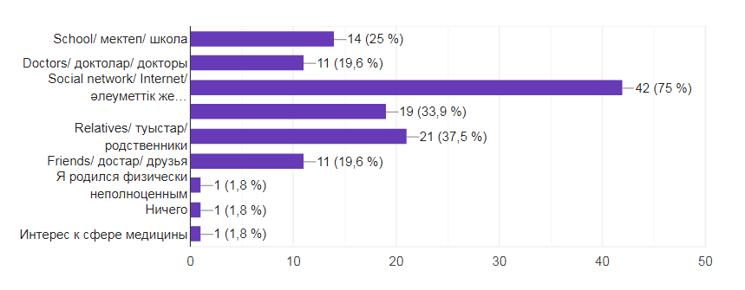

The 5th question illustrates the rate to which each aspect of health literacy is provided by school. It can be concluded that public schools pledge a lot of efforts in teaching physical education (48-yes) and healthy diet(33-yes). However, the topics of getting services at hospitals and conduct a self-treatment are not usually taught, from the perspectives of 34 students. Regarding the issue of how to act in emergency situations, 25 students out of 49 claimed it is not given by school.
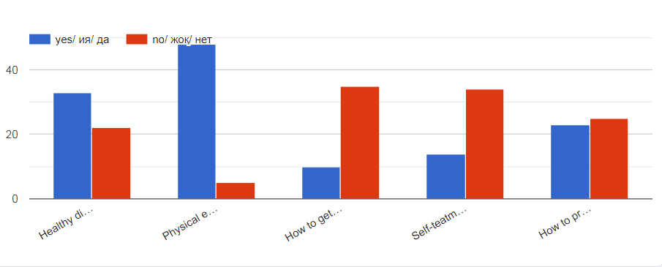
The next question estimates the sufficiency of information by school. The range goes from inadequate to sufficient. From the table we can see that students are satisfied with the amount of information on Healthy diet and Physical education, yet consider other three aspects lacking.
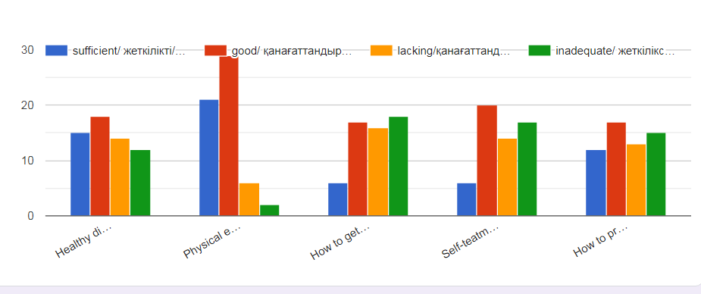
The last question with quantitative data estimates the rate to which students think the information given by school is enough to pursue healthy lifestyle. 40,7% of respondents, which is the biggest showing, are not sure in their ability to stay health. The other 40,7% are sure and completely confident in their knowledge gained at school. Nearly 20% of respondents think they have not formed enough knowledge at school to remain health strong.
The 9th question is the only one which gathers quantitative data and was aimed to identify possible measures that schools should imply in order to ameliorate the promotion of health literacy. The vast majority(16) thinks that school doctors should hold meetings and lectures on a regular base. Other popular suggestions are: adding a new subject for health literacy, providing additional sources (banners, flyers, booklets), and integrating health literacy related topics with school subjects like biology and chemistry and class works.

Interview
Appendix II
Parents
In this section interviews with 3 parents of students of public schools from different regions of Kazakhstan will be described. All members remain anonymous and responded to the same set of questions.
All three members answered that the school where their children study does not acquaint parents about what is adopted in order to teach health literacy to their students. Children of only one parent tell about how health related topics are integrated in school subjects, yet this parent assumes it is insufficient amount of information. All parents agree that the only time when they are aware of health related events are vaccinations that require parental permissions. Regarding the question of what health literacy from the point of parents, the answers implied self-treatment, giving emergency medical support, basic rules of hygiene and physical education, specifics of puberty in boys and girls. Interviewees claim that parents and parental committee do not show any enthusiasm in promoting health literacy and the only way that schools imply to increase the awareness are through chats in social media like Whatsapp. Generally, parents agree that schools react on emergency situation like coronavirus flash quickly, but not effectively enough. On the question of how parents can contribute in this process next methods were suggested:
- Parents can conduct lectures themselves or invite specialists, make connections with school administration and track this process at school and at home.
Also, interviewees think that school should do:
- Hold lectures with doctors
- Organize events on topics of drug abuse, alcohol, sex education etc.
- Integrate health topics in syllabus and extracurricular activity.

School Doctors
In this category 3 school doctors were interviewed.
According to school doctors, school should teach healthy diet, physical education, giving emergency medical support. Students also should know how to act in cases of viruses and illnesses, how to prevent illnesses, and their diversity and symptoms. Interviewed doctors only consult students when they come with complaints and when it is vaccinating time. Only one of 3 doctors provides lectures and gatherings when there are threatening (for instance, splashes of illnesses in spring).
All 3 interviewees explain their low activeness in promoting health literacy by lack of support and demand from school administration. By support they meant funding (materials, equipment) and dedicating special time in students’ schedule. The measures that can be adopted by doctors are: visiting classes and providing lectures, additional sources like flyers and advertising methods, conducting events like games, marathons and trainings (teaching emergency services)
School administrator
The last interview was with the school administration representative, who thinks that health literacy is the way people can find right treatment, have enough knowledge to prevent illnesses and make decisions. Administrator claims that as health literacy rates do not affect the ranking of school, very little attention is devoted to this issue compared to the education. School administrations do organize events like Healthy day and lectures about alcohol and drug abuse, yet consider that not enough. They state that there is not enough funding of schools to give the sufficient knowledge, the money and time is predominately spent on education, since the health issues at least can be lead by parents. The interviewee thinks the school administration should have more connections with parents and have more demand from school doctors.

Overall, survey illustrates the students’ view on how effectively schools promote health literacy, whereas interviews show what is implemented by different significant roles in this process and includes possible measures. Both qualitative and quantitative data were gathered and presented.

Conclusion 416

- Do schools promote students with relevant information (about diet, physical education, medical support, and self-treatment)? ​
Survey and interviews with school doctors show that mostly healthy diet and physical education are taught properly and sufficiently, whereas other 3 aspects are assumed not effective. In the context section it was stated that health literacy rates in public schools are low; and this finding does not only confirm this statement, but also precisely illustrates which aspects should be improved, which makes the finding useful in achieving the aim of the research.
- How effectively do students process and adopt the theory that refers to Health Literacy?
The survey conducted among students has shown that only 40% of students consider themselves enough literate to be healthy. This supports my hypothesis, as it shows low adequacy of the health related information which is provided by the schools. However, the research tools did not help in finding the information of how students use and interpret the gained knowledge about health literacy in their real life.
- What students and parents consider about the approaches schools use to promote health literacy?
Students seem to be unsatisfied with the adequacy of the health literacy promotion, as it was hypothesized, whereas parents do not appear to be enthusiastic and are indifferent in contributing in the process of teaching health. This was unexpected, since schools and parents committee, from the view of parents and school administration, have tight relationships and collaboration, and parents commonly are worried of their children’s health. This is important finding, since in the context it was stated that schools and parents should both be engaged in process of promoting health literacy and co-operate.
- What could be done to improve present measures, making them more effective on practice?
This question was obtained by all research tools and different methods were suggested. The most effective and demanded approaches appear to be: lectures with doctors, integration of health literacy with school subjects, and adding a new subject of health literacy. This is one of the most significant findings, since identifying potential methods of ameliorating the issue of poor health literacy promotion was the main aim of the research.

Conclusion
The hypothesis of the research was confirmed and the main aims were reached, thus the conclusions based on the findings seem to be adequate. Even though there is a question regarding the usage of the information by students that was not discovered fully, other questions were scrutinized from different views and suggestions on improvements were given.

Evaluation 505

Survey
The survey played a significant role in concluding which aspects of health literacy promotion are taught sufficiently and which need improvements, which was aimed by the research. Since students of public school were the target group, the responds on yes/no question and the question that identifies which aspects of health literacy are covered at school, seem to be valid, as they are not subjective. However, conclusions based on evaluating questions – evaluating the sufficiency and quality of specific aspects of health literacy- may be ambivalent, since some students could be biased while responding or have lack knowledge. For instance, a student that stated himself literate enough to keep healthy lifestyle may actually be not from perspective of doctor. Instead of this it would be better to ask does student want health literacy to be promoted more sufficiently in their school and do they think it is important. This would be a considerable change, since it answers to one of the research questions and could contribute in eradicating the bias that health literacy can only be promoted at school. There were also some useless answers in open-ended question which asked to suggest improvements, yet there were enough responds to come up with this aim.
Interviews
Interviews were conducted among 3 different social groups- parents, doctors, school administrator-which is an advantage, since the issue was scrutinized from 3 various perspectives, where one of them is expert of health and two others are tightly related to the school, what makes their responds predominately valid. It was beneficial, because the responds supported not only the secondary research, but also the conclusions based on survey among students. The conclusions based on it were significant, because they answer to the research questions like the attitudes of parents, possible improvements. Even though, I assume that in interviews with parents responds were a bit biased, since in the initial questions it was identified that they are not informed about the measures that are implemented in schools, thus they strived to predict and give stereotyped responds without backing up them with facts. However, even this downside was useful in another case. It made parents think about how they could contribute and suggest it as potential improvements, what was stated in the context and aimed. The responds would be more valuable if parents were given an explanation of what is health literacy and aims of the research in a text format few days before the interview, instead of explaining these points while the interview. Thus, they would be more engaged and would help shun the aberrations from the topic and questions.
Generally, the validity is acceptable, since the predominating part of the research questions were answered by facts and views of experts. Although, there are responds and conclusions that are possibly biased, those were concluded for more detailed description and to get more relevant suggestions by the end of the research, which means that they do not change the main point of the conclusion. That is why the inferred points can be applied in further.

Further research 390

To begin with the way of how I would improve the used tools, the amount of survey respondents would be expanded, so that to be sure that responds are not biased, there was the data which is more close to the truth and students of more regions would be covered. However, If given time and access to abroad students, I would move the focus of the research from public schools of Kazakhstan for more countries. This would be beneficial, because the issue of low health literacy is ever-present, as it was stated in the secondary research. What it implements is that the research would help identifying the possible measures that ether could be adopted generally in any school. The significance of this would be that the research would cover the question of what is weak in health literacy promotion and how to improve it and if used, then the new generation would possibly be more health literate and responsible, which is profitable from economical and social perspectives and would contribute in avoiding global pandemics and similar issues. In addition to this, I would conduct test to identify the current level of health literacy of students in different areas, and then compare the systems between the more successful and poor, or compare the promotion of health literacy in countries with different economical development, so that to see what can be integrated. The profit of that would be the exchange of experience and there would be no reason to test the measures which saves the time and sources.
Overall, I have learnt that school is a very effective place for promotion health literacy, if given opportunity. Parents and adults who are engaged in students’ lives should be more enthusiastic in these aspects. More to the point, I assume that the methods suggested in this research are valid enough to be adopted by schools, not only in Kazakhstan but in other countries too. I also have come to an idea that some measures could be required from schools on a scale of law or convention, since students spend the majority of their time when they grow and develop at school and so there should be right conditions. The belief in my perspective that the health literacy promotion is vital in schools has become even stronger and I see how it can be improved.

Bibliography

U.S. Department of Health and Human Services, Office of Disease Prevention and Health Promotion. National action plan to improve health literacy. Washington (DC): Author; 2010.
Healthy People. (2020). National Library of Medicine. https://nnlm.gov/initiatives/topics/health-literacy
Healthy People. (2020). National Library of Medicine. https://nnlm.gov/initiatives/topics/health-literacy
Matricakz. (2020). Medical literacy - base of health of Kazakhstan citizens. http://www.matritca.kz/news/68766-medicinskaya-gramotnost-osnova-zdorovya-kazahstancev.html
Nikolina Dukić, Andrea Arbula Blecich & Ljerka Cerović. (2013). Economic Implications of Insufficient Health Literacy: https://www.tandfonline.com/doi/pdf/10.1080/1331677X.2013.11517643
Prim Care Companion CNS Disord. (2015).
Impact of the Doctor-Patient Relationship: https://www.ncbi.nlm.nih.gov/pmc/articles/PMC4732308/
World Health report. (2007). Walden University. https://www.waldenu.edu/online-masters-programs/master-of-science-in-nursing/resource/msn-insight-why-is-global-health-important-to-nurses
​Guest, C. (August 2019 r.). cvent blog. Получено из https://www.cvent.com/en/blog/events/qualitative-vs-quantitative-research-methods
Jamshed, S. (2014). NCBI. Получено из https://www.ncbi.nlm.nih.gov/pmc/articles/PMC4194943/
Qeryz, 2020. (б.д.). Получено из https://qeryz.com/blog/survey-pros-cons/

Appendixes

Appendix I
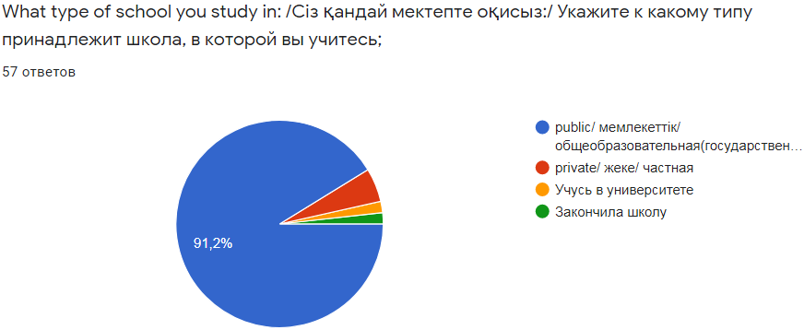
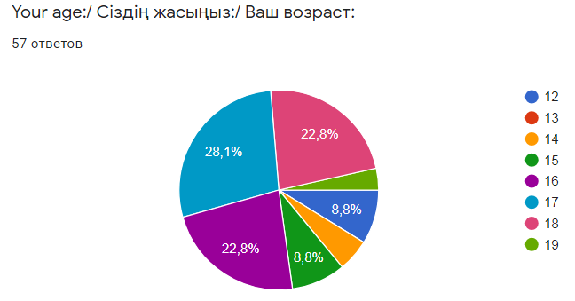
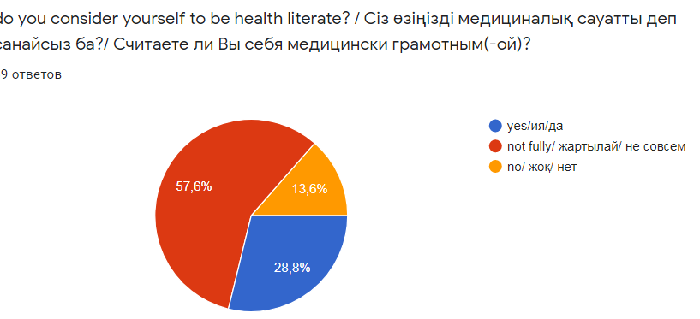
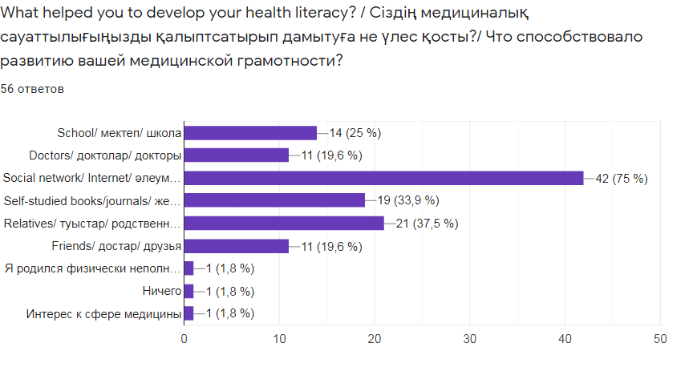
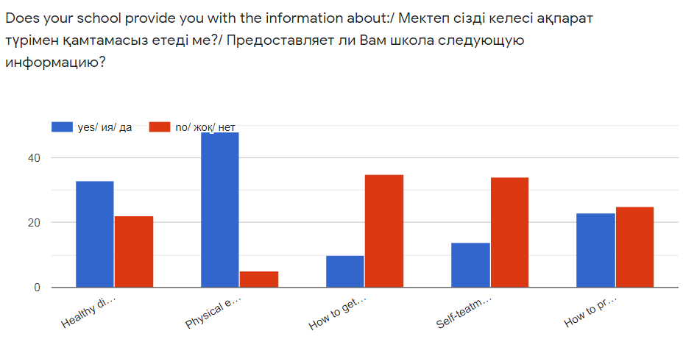
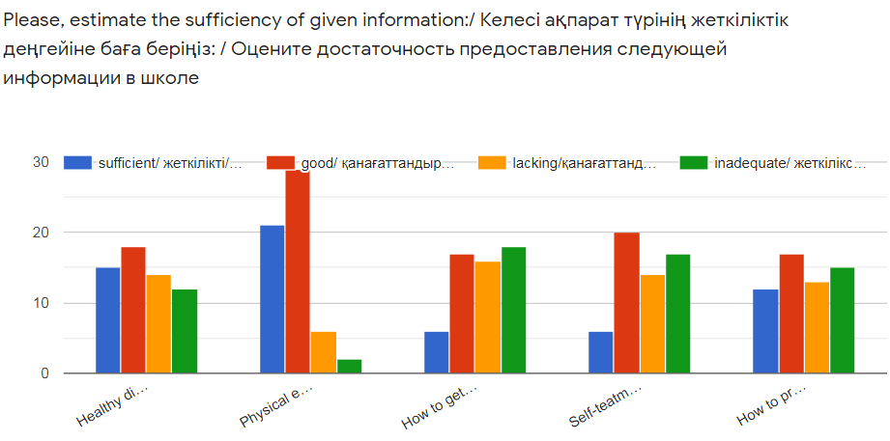
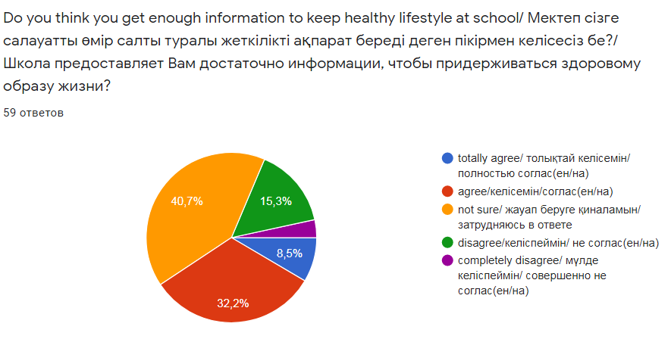
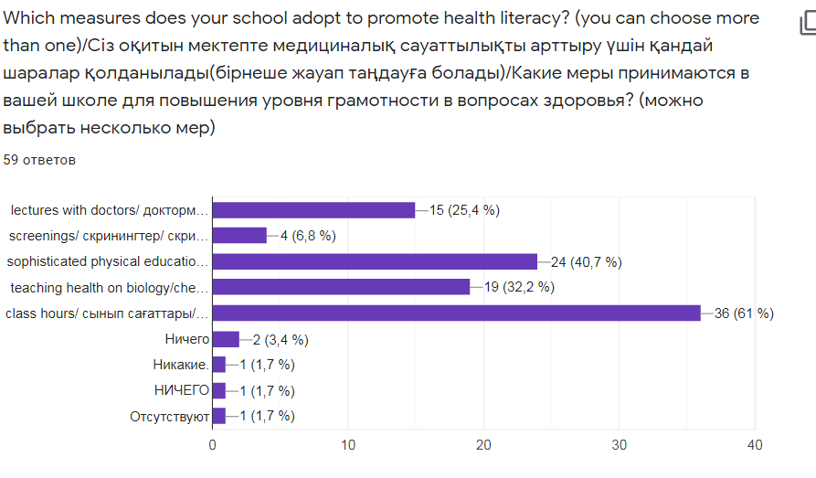
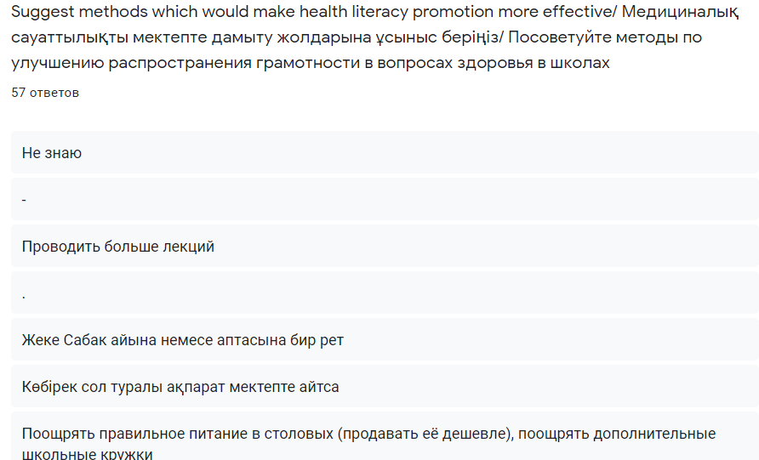

Appendix II
Parents
- Are you acquainted with the measures that school adopt in order to educate students healthiness?
- What is health literacy in your view?
- Do parents show interest in how healthy students are at schools?
- What should be implemented to improve present measures of health literacy promotion at schools?
School Doctors
What type of information you promote in order to keep healh literacy rates high?
What measures do you use to promote health literacy?
Do you think this measures are effective enough for student to be able to practice these knowledge in real life?
Does the school administration support the health literacy promotion?
What should be implemented to improve present measures of health literacy promotion at schools?
School administrator
- What is health literacy in your understanding?
- Can you describe the structure of the health literacy promotion process at your school?
- Do you think it is efficient for students to be healthy?
- What should be implemented to improve present measures of health literacy promotion at schools?

