Problem of home’s quality:
How much are people satisfied with their home.
Nurlankyzy Aiym
Nazarbayev Intellectual School

Word count:3686

INTRODUCTION

It is a funny thing coming home. Nothing changes. Everything looks the same, feels the same, even smells the same. You realized what’s changed is you.”
© F. Scott Fitzgerald

House can be made from bricks and beams, but home is constructed by hope. However, nowadays most people are suffering because of lack home. That is why, they must live in eerie conditions. What is terrible, among them exist groups as family having children or with only one breadwinner. Majority of people stay in queues, where average waiting period is almost 10 years. It proves that problem is important and relevant as ever. Majority of people complain about home’s quality after moving to new apartment. Forums of residents, videos on YouTube and in social networks — and now everyone knows where the crooked walls, terrible sound insulation and everything is bad. But even worse — an emergency new building. The house has just been built, and it is already an emergency. the situation is more complicated, when prices for home is too high, but quality is too bad.
From my vantage point of view, it seems that system of construction of houses should be improved. I try to find to what aspects needs more attention and how well are they built by using opinion of respondents.
My dream is to have my own house. I expected to receive from this research deep knowledge about houses. To what aspects should I pay attention while choosing it.
My research paper is expected to help to identify the level of satisfaction. It can be addressed towards ministers of Republic of Kazakhstan to inform them about current problems of citizens. Also, people can get benefit from my research as people, who have already gotten homes can share thoughts, as well as their experience. one of the most important problem is home’s quality.
I believe that If every person has their own high- quality houses, people will be happier, because home is index of how well people are living. Also owning a home will increase the level of satisfaction with their life.
Context
Nowadays, homing issue has become pain for majority of people, therefore they must live in terrible conditions, or rent expensive apartments. As a solution, many programs were initiated by government. However, the quality of homes is still under the question, as many people complain about home’s construction after moving to new apartment.
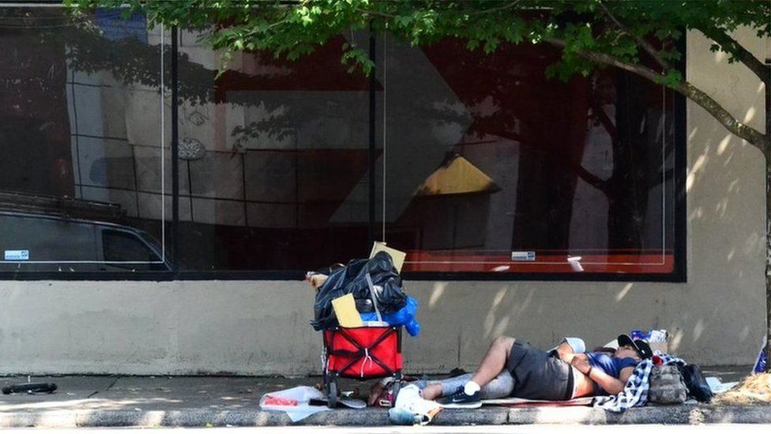
Day by day, the problem of homing is becoming more and more relevant. This problem exists in all countries all around the world. There are 200,000 homeless people living on the streets alone. in South Africa as 2015 (DW, 2019) whereas in USA, more than 553,700 people were homeless on a single night across the US, according to the Department of Housing and Urban Development (BBC, 2017).
Most countries are suffering because of low quality houses. For example, it is better to demolish everything and rebuilt in Africa. It will be much cheaper, as citizens even do not have efficient water, electricity supply, garbage collection system. That is why, most houses are constructed among garbage, even some of them made of trash. (LiveJournal, 2016). The house is very quickly covered with mold in Turkey. Overall poor construction quality is noticeable (жить, 2020).
The share of Russians who are satisfied with their housing increased in 2019 and amounted to 52%, every fifth citizen of the Russian Federation is ready to take a mortgage (19%), according to a survey by the Public Opinion Foundation. In 2019, the share of Russians who are satisfied with their housing increased to 52%. The number of citizens dissatisfied with their housing this year decreased to 8% (in 2018, there were 11%), and the share of those who consider their conditions tolerable also decreased (39% in 2019 and 44% in 2018) (новости, 2019). However, there are regions, that contains emergency houses, which have been built recently. One of them is village of Izvestkovy in the Jewish Autonomous Region, two brand-new houses built in 2014 were declared emergency in 2018. (Москвы, 2019)
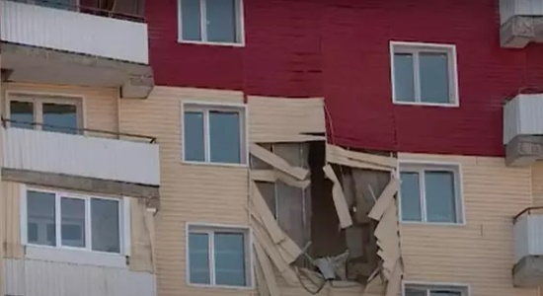
Having a house is extremely important, therefore people do their best to purchase it. For example, some people in queues to get home. average time is almost 10 years. As of today, 529.61 thousand people are on the waiting list in the akimats of the republic in this system. Due to state support, 14,522 housing units were distributed in 2019, and 4,284 apartments were distributed in the first half of 2020 (tables are attached by region and category). (Казахстан, 2021), that is why people tend to use programs to receive their home’s keys faster and easily. In the meantime, it is understandable that nobody wants to spread the money that was collected with difficulty on unprofitable things. Residents of a new building in Ust-Kamenogorsk complain that the building is literally falling. This issue can be investigated through social lenses and residents’ perspectives, as it effects on their life. residents of this building now spend money every month not only on credit, but also on repairs. (Манджиатори, 2021) "Our neighbor from the 7th floor is already moving out to a rented apartment because of the cold. The whole house is problematic. We applied to the Kazakhstan Mortgage Company, they were the main ones on this construction - but so far they just promise," said Berik Tolembek, a local resident. Most of residents tried to refuse the purchase, but it did not work out. In response to the complaints, the prosecutor's office promised to conduct a detailed check. Economical lenses, and company, that is responsible for building or government’s perspective, as it is too costly to repair whole house. at the same time, representatives of the responsible company say that it will not be possible to call the developer to account, since the company that built the new building lost its license and became bankrupt. (Манджиатори, 2021).It is not the first and the last situation. Such tragedy occurs everywhere. For instance, almost 40 thousand people have suffered in Russia due to the largest bankruptcies of developers over the past 10 years, according to the results of a study by RASK, available to RIA Real Estate. According to the conclusions of RASK, the" leader "in the sad rating of bankrupt developers in the housing market is the group "SU-155", due to financial problems of which 30 thousand people were among the affected co-investors (Гаврилова, 2017)
Residents of a new building in Ust-Kamenogorsk complain that the building is literally falling. (Манджиатори, 2021)
Taking everything above into account, government should take urgent actions to construct homes with high quality of homes and relatively low prices. And people can suggest ways of improvements while primary research.

Aims
The main purpose of this research is to identify level of people’s satisfaction with their new home and find out how what measures are being taken to deal with the problems of houses in the state of emergency.
- How much are people satisfied with quality of their houses?
- What are the attitudes of the general public to buying newly built houses by state programmes?
- How is the issue of emergency houses can be addressed?
- What frequent problems do the residents of newly built apartment residents face?
Answering all of these question makes an opportunity to achieve my main aim, because as a result we can get information that is useful to evaluate home’s quality and find out possible solutions. My hypothesis is nowadays most people are not satisfied with their home, because having problems with quality is not surprising thing.
Methods
The purpose of this research is to find out how much are people satisfied with their home and identify what measures can be taken to solve this problem.
I will describe and justify the choices I have made in developing a mixed, semi-structured interview, survey and data analysis-based study that helped me reach my main aim.
This research uses a mixed (qualitive and quantitative) research approach, as the research was conducted to find data about current home’s quality. The research paper includes information about the most common issues of the homes and gives an opportunity to determine people’s attitude towards purchasing newly built homes, as a result it was be possible to figure out the level of occupant’s satisfaction with their home.
First, I rose a question of problem of home’s quality and then developed a research purpose aimed at that problem, and then research questions working to achieve that purpose. After that, I thought about which research tools can be used for gathering data in base of my research questions. I generated a survey, pilot tested it on three people. 55 people have participated in it. Next, I used the information from the survey to develop an interview that I administered to residents of new built homes.
The first method was survey. Thanks to survey, I was able to identify the most frequent problem and people’s suggestions easily and quickly, and the level of generalization was quite high, as it covers 55 various perspectives. I identified different viewpoints in shortest period (2 hours) The survey was conducted in google. Form (online), that allows to analyze data collected more easily, using diagrams and pie charts etc. for instance: the frequent problem can be deduced faster, according to overall number of chosen options. Furthermore, all need to participate is google account, which most people already have. The sample group is people who have own home. One of the most important reason of choosing this sample is that occupants know about the issues of their home very clearly and can describe it. the link was shared using social media. Most people (approximately 70%) feel responsible and were ready to participate. However, there were some people who do not relate to it as important thing. One of the weaknesses of this method is that it lacks in quality and by doing it online, it cannot fully capture emotional responses or feelings of respondents.
An interview was conducted with 3 people (occupant of different homes) in which I did semi-structured interviews of 2 residents who have experienced to live in newly built home. this sample was chosen because three completely different homes’ resident’s living condition was compared with each other. I selected interviews as the appropriate method for this study because it gave me an opportunity to control conversation. It means, I could ask extra questions for clarifying, as a result I gathered detailed information about home’s quality. The interviews contained information about today’s frequent problems and figured out measures, that can be taken to deal with it. Compared to the survey, it allowed me to ask open-ended and personally tailored questions for more details in a more conversational manner, as we had face-to-face conversation. And answers of the residents were more trustworthy. The interviews lasted between 7 to 10 minutes for each interviewer. However, semi-structured interviews took relatively longer than other methods.
The documentary analysis is used as third method. It is used for not only verifying information about quality of homes, but also studying companies, that built these apartments sample is information derived from official site, because documents are stable, meaning they remain unchanged and can be read and viewed multiple times. I studied https://www.gov.kz/memleket/entities/vko-kurylys, and I have collected information about investment and their plan per year. One of the main reasons why this website was chosen is that it was reliable source and contained statistical data. First step was to gather up all relevant documents, then explore their agenda, after that to ask questions about document (e.g., who produced it? Why? When?), and finally explore content. This method was time-consuming, nevertheless had provided the necessary information.
Anonymity is less important in my research, because sharing your opinion and telling your problem is not guilty thing. However, if the respondents do not want to show their name, I will not insist them. Anonymity can give honest responses, as people will share their perspectives freely. Nowhere people’s names are mentioned and personal information or questions about their private life was not asked.
In conclusion, all three research methods that were used help in answering main research questions and collecting all required information.
Results
Attitude of general public of purchasing newly built home is good, rather than bad. According to the survey, the number of people who prefer living in newly- built houses was higher (60%), than people, who want to live in secondary houses (40%). Interviewers suggest, advantages of living new homes(table1). According to that, it [why people prefer to live in houses under construction than secondary housing] can be related to the fact that they are new, as nobody has used them before, furthermore the region, where is located these houses is quite eco-friendly. some people are not satisfied with their home, as they are ready to get their money back, instead of home. it proved, when it is asked if they had a chance to get their money back from occupants of newly built house, answers of respondents divided into 2 groups. 27% of people claimed that they would leave home, however 22% said that they would choose money.
One of the main reasons, why people do not want to live in brand mew houses is quality, and this can relate to low money sharing for building. The third method “data analysis” can verify this data. https://www.gov.kz/memleket/entities/vko-kurylys was explored. Results showed that only about 5000000 was invested per year (Шығыс Қазақстан облысының құрылыс, 2020 жылдың желтоқсан айының бюджеттік жоспары, 2020). And that is not for one project, but for several ones. It is expected to build more than 160000 buildings, and about 90000 of them multi-storey.
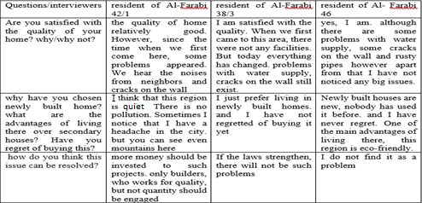
apartments by 2020 (басқармасы, 2020). Moreover, first quarter of 2020, 487 thousand m2 of housing was commissioned in the region at the expense of all sources of financing, with an increase of 110% compared to the corresponding period last year (Шығыс Қазақстан облысының құрылыс, 2020). The demand for house is gradually increasing by the period. however, money that was shared for building is not enough.
Table 1 interview.
Survey results revealed that the most common and frequent problems are cracks on the wall, sounds from neighbours, dampness. Apart from that respondents are mentioned that the house is cold in winter, as there is few equipment for steam heating, and it is located far from the centre of the city, also problems with water supply. interviewers have confirmed it. And it was obvious that all 3 buildings have common problems that listed above.
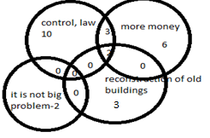
According to the survey result(table2), many people (35%) consider that problems can be resolved by increasing control over building companies and materials, introducing criminal liability for builders and hosts of low-quality housing. 10,3% people believe that changing the scheme of construction or reconstruction of old buildings, instead of new homes is best solution. 20,6 % of people think that spreading more money can prevent construction of low-quality homes. 3 people mention that control and money is extremely important while solving this issue. Interviewers support them. But there were several people, who have not found it as a relevant problem.
Table 2 how problem can be resolved.
Overall I conclude that most people are satisfied with their quality of their homes. however, there are some people who are not satisfied with their quality of houses under construction. It can be verified by answers of interviewers and survey’s result. As shown in figure 1, the number of people who evaluate the quality as 4 and 5 out of 5 were 36,4% and 25,5% respectively, whereas 20% of the respondents rate it as medium. And rest of the people (18,2%) answered that quality is bad, they put 1 and 2 out of 5(9,1% for each option).
Figure 1 the level of satisfaction with quality

Conclusion
Initially, my personal bias was that people would be happier if they had well-constructed home. And it is verified while primary and secondary research. As many people have found this problem to be one of the most important and relevant, because no one wants to invest their money to an emergency home.
Moving to aims questions:
- How much are people satisfied with quality of their houses?
Even so my hypothesis was that people will not be satisfied with their home’s quality, as number of forums of residents, videos on YouTube and in social networks about low quality of homes is increasing day by day, it was explored through two methods that were conducted while primary research that people are satisfied with their house. Firstly, survey was conducted among 55 citizens of Oskemen, and data was confirmed by both interviews with 3 occupants of three different new-built homes. it can be generalized for Oskemen’s citizens. But secondary research said that problems of quality exist in most countries all around the world So, this information has the moderate level of generalization, it covered perspectives of Oskemen’s houses’ residents, it is still unclear opinion of other region’s people. Even other region’s citizen, even so there was an attempt to identify it while secondary research.
- What are the attitudes of the general public to buying newly built houses?
Attitude of public towards purchasing new built house is divided into two groups. According to the survey, 60% of citizens are ready to buy new house, but the rest of respondents claim that they prefer secondary housing. The interviewers also confirmed this data. The main reason of choosing it eco-friendly region and the fact that it is new. The level of generalization is also medium because it is only Oskemen’s residents’ points of view.
- How is the issue of emergency houses can be addressed?
According to the survey and interview, most people think that this problem can be resolved by strengthen laws, and company should take responsible for construction of homes. As a next solution, it is recommended to spread more money for building. during the third method, it is proofed that a little money is invested towards construction. Reconstruction of old buildings, instead of new one can be served as one possible settlement.
- What frequent problems do the residents of newly built apartment residents face?
Survey results revealed that the most common and frequent problems are cracks on the wall, sounds from neighbours, dampness. Apart from that respondents are mentioned that the house is cold in winter, as there is few equipment for steam heating, and it is located far from the centre of the city, also problems with water supply. interviewers have confirmed it, that means all 3 buildings have common problems. Even so interview was conducted among only three new building residents, survey covered quite a lot, 55 people’s perspectives. That is why, the level of confidence and generalization is low.
Evaluation and Further Research
My research paper has own strengths and weaknesses.
First, survey’s questions were directed to people who own houses. Respondents can evaluate their home’s quality using ranking questions, whereas multiple choice questions gave an opportunity to find out vital issues of newly built homes. Even so, survey included only 7 questions for 5 minutes, the research questions were answered. the survey questions were clear, understandable, short. However, the number of respondents should be increased up to 100 to get more generalizable data, as results may be changed by the larger amount of survey participants.
interview was conducted with 3 residents of different apartments. As second method semi-structed interview was chosen. Thanks to possibility of asking various open-ended question, they were able to tell me about their current homes state in more detailed way, that is why the frequent problems and the resident’s level of satisfaction with their home were successfully identified. However, it is better to include other perspectives. For example, opinion of workers in companies, that are responsible for construction. To discover the problem from different perspectives and get more specific information, interviewers should be changed.
Document analysis helped me to gather more statistical information, as a result it was possible to explore the topic deeper. Despite of the fact that the chosen website is an official site and credible, one of the drawbacks of the research was that only one website is used for this method. it is better to explore other documents improve the confidence of conclusions. Strength of the research was that all the main conclusions were supported by at least two research tools and research questions were answered and confirmed with facts and evidence. All research questions were answered. According to them, a brief and good conclusion on a local scale was made, because generalizable level is moderate (survey included enough participants, all used sources were credible), but it cannot be applicable for whole Kazakhstan.
However, I would like to make a deeper analysis of the problem of quality. My research paper discovered the issue on only local scale, opinions of Oskemen’s citizens were included. Generally, I think that I can make my project much bigger and worldwide by receive data from people in different countries
In order to improve the existing work, I need change the one research method: the data analysis. To get more helpful information and make the project more productive and efficient I could have done interview with people who work in this sphere. I believe that more detailed information about construction can be gathered with help of semi- structured interview. I would like to conduct focus group discussion with the residents of the homes. It could improve the quality of the gained information because it helps to avoid from repetitiveness of the same idea about quality and its generalizable level will be higher than interview. Because correlation between interview and survey show that the chosen three people may not represent the idea of whole group.
The outcomes of the research did not change my perspectives. I was so surprised, the results reflected that the average level of satisfaction of residents with their home was high, although they have a lot of issue related to quality and overall home’s state. And I believe that the problem can be resolved only by using special strategies.

Список литературы
BBC. (6 December 2017 г.). US homeless people numbers rise for first time in seven years. Получено из BBC: https://www.bbc.com/news/world-us-canada-42248999
DW. (2019). Получено из South Africa: From the ashes of apartheid: https://www.dw.com/en/south-africa-from-the-ashes-of-apartheid/a-48462055
LiveJournal. (2016). Самые большие (и ужасные) трущобы Африки! Получено из Самые большие (и ужасные) трущобы Африки!: https://varlamov.ru/1920185.html
басқармасы, Ш. Қ. (23 December 2020 г.). Шығыс Қазақстан Облысының құрылыс және сәулет басқармасы. Получено из ШҚО бойынша 2020 жылдың желтоқсан айында барлық қаржыландыру көздері есебінен тұрғын үйді пайдалануға беру: https://www.gov.kz/memleket/entities/vko-kurylys/documents/details/106429?lang=kk
Гаврилова. (04 October 2017 г.). Недвижимость РИА новости. Получено из Десять крупнейших банкротств среди российских застройщиков жилья: https://realty.ria.ru/20171004/1506105987.html
жить, г. н. (16 March 2020 г.). Яндекс. Получено из Дома обычных турков. 5 минусов жилья в турецкой провинции, из-за которых я не захотела жить в этой стране: https://zen.yandex.com/media/gdenamzit/doma-obychnyh-turkov-5-minusov-jilia-v-tureckoi-provincii-izza-kotoryh-ia-ne-zahotela-jit-v-etoi-strane-5e6e8543a398c131b6392448
Казахстан, м. и. (19 January 2021 г.). GURK.KZ. Получено из Вопросы и ответы о государственной программе обеспечения граждан гос жильем: https://gurk.kz/news/voprosy-i-otvety-o-gosudarstvennoj-programme-obespecheniya-grazhdan-gos-zhilem
Манджиатори, Л. (13 January 2021 г.). nur. kz. Получено из Новостройка разваливается в Усть-Каменогорске: https://www.nur.kz/society/1893431-novostrojka-razvalivaetsa-v-ust-kamenogorske/
Москвы, Н.-М. н. (5 July 2019 г.). Опасные новостройки: почему новое жилье строят так плохо? Получено из https://zen.yandex.ru/media/novostroy-m.ru/opasnye-novostroiki-pochemu-novoe-jile-stroiat-tak-ploho-5d1f19f962ca7100ad915889
новости, Н. Р. (2019). Недвижимость РИА новости. Получено из Доля довольных своим жильем россиян выросла до 52%: https://realty.ria.ru/20191030/1560398991.html
Шығыс Қазақстан облысының құрылыс, с. ж. (22 December 2020 г.). 2020 жылдың желтоқсан айының бюджеттік жоспары. Получено из 2020 жылдың желтоқсан айының бюджеттік жоспары: https://www.gov.kz/memleket/entities/vko-kurylys/documents/details/106172?directionId=2335&lang=kk
Шығыс Қазақстан облысының құрылыс, с. ж. (23 November 2020 г.). Шығыс Қазақстан облысының құрылыс, сәулет және қала құрылысы басқармасы. Получено из Ақпарат ШҚО бойынша 2020 жылы тұрғын үй құрылысы бойынша: https://www.gov.kz/memleket/entities/vko-kurylys/documents/details/74079?lang=kk

Appendice1_Interview
Let’s start our conversation. Interview will be conducted completely anonymous. You can feel free, and I hope that your answers will be honest and extended. Your responds are extremely important while designing conclusion.
- How long have you been living in this house?
For two months
- Have you noticed any problems with quality? How are you satisfied with your home?
Yeah... a lot of problems have appeared, even so I don’t find this issue as extremely important one. Maybe our house isn’t perfect, but I think that it has relatively good quality. And the problems can be resolved. I completely satisfied with my home’s quality because they are warm and spacious.
- Have you ever regretted of buying it?
No, not yet!
- You have mentioned that you have faced some problems. Can you list them by urgency and relativity?
One of the vital problems is cracks on the wall. And then I want to highlight the problem of water.
- let me clarify this moment what do you mean by problems with water. Is that issue of water supply or something wrong with pipes?
Pipes have rust and water is not for drinking.
- Why did you choose newly build house? After all, you were able to buy house using secondary housing.
I think new house is better. Nobody had used them before you lived, and the region is eco-friendly.
- How this problem can be resolved?
I don’t think that this problem is really important. What you need is to be patient
Thanks for your precious time and respond!
Interviewer2
- How long have you been living in this house?
For two years… approximately
- Have you noticed any problems with quality? How are you satisfied with your home?
I am satisfied with the quality of my house. All the new buildings will have problems. We expect them to be appeared. But problems are not so big, and I believe that they are resolvable. I have noticed cracks on the wall, and I hear noises from neighbor. This problem worries me a little bit.
- Have you ever regretted of buying it?
No, never. If I had chance to choose home again, I would not change anything.
- Why did you choose newly build house? After all, you were able to buy house using secondary housing.
In my opinion, new things are always the best, because anybody had not used them before. Personally, I just like new things. I just feel happy of living in new houses, and they are quite convenient
- How these problems can be resolved?
What we need do is to strengthen the laws and control the whole process of the construction, because it is not secret that corruption is one of the relevant problems to our country. If government control share of investments, I believe, that the new homes will have high quality and lower price.
Thanks for your precious time and respond!
Interviewer3
- How long have you been living in this house?
I don’t quite remember. Four year… approximately four years
- Have you noticed any problems with quality? How are you satisfied with your home?
I am satisfied with the quality of my house. Even so our home has some problems related to home’s quality. The region and home’s state are improving. Because when we first came to our new home. there were a lot of problems, such as problems with water and electricity supple. Often our home is left without electricity. There were not any amenities. We did not used to have any shop near our home. but today everything is changing.
- Have you ever regretted of buying it?
No, I have not!
- Why did you choose newly build house? After all, you were able to buy house using secondary housing.
As its name says, newly built houses are new. they are not old construction. And the second reason why I have chosen new homes, they are built in such eco-friendly region. Look (interviewer is pointing mountains) you can see the mountains here. Beautiful view, isn’t it? especially in summer. I noticed that I have headache in the city. but this place is located far from factories in the city and quiet.
- How these problems can be resolved?
I think, more money should be invested for construction to purchase high-qualitive materials. And only responsible companies, who works for quality, not for quantity should build these houses
Thanks for your precious time and respond!
Responds were categorized by 4 groups. They are more money should be invested for construction, improving law and control, and reconstruction of old buildings/ apartments and it is not big problem. There were some responses, which are not appropriate. They were excluded

