The effects of TikTok and Instagram have on the perception of a body of teenagers and

The reasons of body dissatisfaction among teenagers.

Tussipkhanova Aidana 11” B”

Nazarbayev Intellectual school of Chemistry and Biology in Ust-Kamenogorsk

Word count: 4666
Introduction
“I don’t have perfect teeth. I am not stick thin. I want to be the person who feels great in her body and that does not want to change anything.” – Emma Watson. Emma Watson told how she feels about her body and her confidence towards her appearance. She loves herself as she is and therefore this attitude supports her mental together with physical health as well. However, I have noticed that not everyone, especially teenagers, accepts their natural beauty as Emma Watson does. One of the reasons for being insecure is probably the effect of social media, namely celebrities such as Kendal Jenner and Gigi Hadid, who represents “ideal” body image. Turning to the aim of this research is to indicate the effect of social media platforms, including TikTok and Instagram, have on the perception of a body.
My motivation for choosing this topic is the changes, which have been in my perception of a body. In other words, this topic always was relevant to me since I was the girl, who was complaining about the face, body, and even my personality. I understand those people, who are facing the feeling of judgment and the sense of worthlessness towards themselves. Therefore, I want to break the stereotypes about the body since for me a beautiful body is a healthy body. Nevertheless, perhaps not everyone comprehends this idea of mine. And so, identifying the effects that media have on teenagers` dissatisfaction with their body would assist me to specify the way of breaking those stereotypes for local citizens.
There is different personal bias. However, in this case, it is suitable to link it with confirmation and observation bias. Confirmation bias occurs during the interpretation of the study data, which may confirm my own idea and opinion towards this topic. Thus, my main hypothesis about the perception of a body can reflect in the conclusion, which might verify my beliefs. The observation bias can be seen in the specific situations with the participants since they are the main sources in my project. For example, if I want to observe the attitude towards their body of my acquaintances to validate my idea, they will know the aim of the project. Therefore, they can alter their genuine actions owning to monitoring them.
This research project emphasizes the psychology of teenagers, which directly connected with their whole perception of themselves and others (their body, behavior, etc.). And so, after conducting the research, it may identify the exact influence of the media on the realization of the appropriate idea of the “perfect” body. I hope this research may show significant positive outcomes and some of my peers would get this idea to change their inappropriate perception of the “ideal” body image.

Context
This study would investigate the impact of teenagers' everyday use of social media, including TikTok and Instagram platforms, on their body image perception. To support this investigation, there are key definitions concerning this topic which would help to understand some terms. The idea of body image refers to “the picture we have in our minds of the size, shape, and form of our bodies; and to our feelings concerning these characteristics and our constituent body parts” (Slade, invited essay “What is body image?”, 2002).
Turning to the main concern is the effects of social media on teenagers’ perception of their bodies. It is known from studies of professors from the Flinders University Adelaide that the internet is breeding a strong socio-cultural force among preteenager girls (10-12 years old), which can cause severe consequences such as body surveillance, increasing diets, and reduced body esteem and depression (Amy Slater, Marika Tiggermann, “Net Girls: The Internet, Facebook, and body image concern in adolescent girls”, 2013).
The next research aimed to examine teenagers of both genders and perceived pubertal timing on body image and adolescent mental health. The experiment included 877 teens from 13 to 18 years with different social and demographic characteristics. The whole concept of the research showed how teenagers cope with emotional distress, exposure to social stressors (for example in social media) and monitor their behavior. Results showed that girls were more stressed and had lower self-esteem compared with boys. Furthermore, the diversity of racial-ethnic groups illustrated different from each other's outcomes. For instance, Hispanics were more depressed and had lower self-esteem than other racial-ethnic groups, whereas African-Americans had the most positive body image and higher self-esteem. Finally, the influence of perceived pubertal timing on a body image covers two main aspects: gender and racial-ethnic groups (School of Public Health, University of California,” Body image, perceived pubertal timing, and adolescent mental health”, 1999). These researches cover social and cultural lens, which represents the impact on people’s daily life.
The study by specialists from community-occupational and social-cultural medicine, showed that body dissatisfaction is strongly associated with bullying behaviour. Their main aim was to assess the connection between body damage and bullying, and the relation of genders. In the experiment were 8050 adolescent aged 11-15 years old, where girls outnumbered boys. Overall, the specialists revealed the strong association between body dissatisfaction and involvement in bullying teenagers, who were dissatisfied with their bodies since they feel overweight, tend to become passive or reactive victims (Jana Holubcikova, “Is subjective perception of negative body image among adolescents associated with bullying?”, 2015). To confirm this tendency, the new study identified the behaviour of teenagers by taking questionnaire from 415 Chinese students from three different stages (junior high school, senior high school, and university). It is known that boys are more likely to act as bully and they perceived the toxic disinhibition, while girls, on the other hand, were more likely to consider abuse and denigration behaviors as bullying, and they were more likely to pass harsh judgment on these behaviors. Moreover, in denigration and rejection cases, junior high school students are more likely to assist victims than university students (Computers in Human Behaviour, “How students react to different cyberbullying events: Past experience, judgment, perceived seriousness, helping behaviour and the effect of online disinhibition”, Volume 110, 2020). Turning to adults and parental involvement in such problem, research from Claire P. Monksa, it is showed that participants discussed the usage of rules and the alleged generation gap in ICT skills when discussing the importance of adult intervention. In the results, what matters is that children believe they can say someone who can support them and providing parents/guardians and school staff with the expertise and trust to work with these challenges is a vital move in that direction. This covers futuristic lens owing to the possible behaviour of teenagers being bullied (Psicología Educativa, “The emergence of cyberbullying in childhood: Parent and teacher perspectives”, 2016).
Riverdale star Lily Reinhart shared her own experience about her body image, and how she struggled by facing criticism for talking about her body. She urged young women to “celebrate each other and ourselves, as we are” by adding these words: “Embracing your natural beauty does not exclude anyone. There is no fine print. You can be naturally beautiful with acne, scars, cellulite, or curves”. She illustrated her perspective about body image and shared it with people on social media. She argued that "There is not one shape that's more beautiful than another. We should be exposed to all body types in advertising and media." - by saying that she wants to help change fake standards about the ideal body. Her audition is beneficiaries, who find inspiration and try to change their notion of “ideal” body image (BBC, 2018).
Jane Caro, Programme Lead for Families, Children and Young people at the Mental Health Foundation said: “Action starts in our families and homes with how we talk about our bodies and about eating, but we also need more regulation of advertising promoting idealized and unattainable body images. Social media companies should urgently up their game in taking practical steps to ensure that the content they promote does not exacerbate body image concerns.” (Mental Health Foundation,” Millions of teenagers worry about body image and identify social media as a key cause – new survey by the Mental Health Foundation”, 2019).
In Kazakhstan, this issue was not deeply exploring. There were few investigations comparing women’s bodies in two different countries. For instance, the study included young women from the USA and Kazakhstan. The study aimed to compare the relationship between Facebook use and body image concerns. Women in the USA were ranked as the fourth heaviest in the world, while Kazakhstan women are estimated as generally thin. What is more, is that especially in Oskemen there is no study on this issue (Yusuf Kalyango Jr., “Body image and social media: cross-cultural comparison between Kazakhstan and USA”, 2018).
To sum up, body image is playing a crucial role in people’s lives. Especially in mental health since some people have body-damage behavior, which deteriorates their health condition. Moreover, some teenagers are shy to express their own thoughts about themselves and cyberbullying in social media can cause low self-esteem.

Aims:
The main purpose of this research to identify the effects of use of Instagram and TikTok social media platforms have on the perception of a body and verify how people react to this issue related to body dissatisfaction (locally and globally). To achieve the goal, the following research questions are going to be addressed:
•How society (local people) understand the notion of “ideal” body image? How can they describe it?
•How people (teenagers and adults) react to this problem of “ideal body image” and cyberbullying in social media?
•What is the teenagers’ attitude towards the “ideal” body image? And what behavioural tendencies/trends of those who create the content about “ideal” body image, and those who watch them (users) can be seen in social media, namely TikTok and Instagram platforms?
Outcomes of the research were intended to increase the awareness of local people to support teenagers’ mental and physical health. Furthermore, this research covers the topic of cyberbullying, which represents the importance of stopping bullying and judging by looking appearance of people on the internet. Based on the research design, it can be predicted that results in the form of information about body image and cyberbullying, will be useful for readers.

Method
For this topic, the key elements were methods for conducting research and therefore it was suitable to use questionnaires, interviews, and data analysis. To check the results from the questionnaire and gather more detailed information about “ideal” body image and people’s approach to this issue, interviews were conducted with people from two age groups to represent a variety of opinions of older and young generations. The last method was data analysis, and this method was conducted for triangulation of data related to social media and teenagers’ behavior within.
The first method was a questionnaire, which is a quantitative research method, assisted in analyzing data from different viewpoints. The anonymity of this survey helped to get more accurate and honest answers. “How society (local people) understands the notion of “ideal” body image? How can they describe it?”- this research question was answered with the help of a questionnaire. Moreover, it is straightforward to identify the relevance of the problem and its causes by the survey. Turning to the population, it was targeted, and so sample there can be students from middle and high schools, not only from NIS, but there were also different schools (public schools) from Oskemen along with the students of the KAZGUU University in Nur-Sultan. This population was chosen to own to the aim of the research method, which is wide reach and contrast opinions. The survey has reached 150 answers, which is valuable for the extensive research. However, the first obstacle during this research was that most of the people were indolent to write more detailed answers together with explanations. Sometimes there were short and incomprehensible answers. This method was verified by the interview since the interviewee can give more detailed information and the answers can be discussed deeper to get precise data.
The second method was an interview, which is a qualitative method. It helped to answer two research questions: “How people (teenagers and adults) react to this problem of “ideal body image” and cyberbullying in social media?” and the first question as the questionnaire. Regarding the population, the sample is the 4 participants: 2 teenagers and 2 adults. Each interview included 9 questions and required a clear and full response. Teenagers were chosen since they are the main source of this project. The adults were chosen to monitor their reaction together with ideas and opinion because parents are taking part and have a significant impact on children’s formative stage of development. The main purpose of the interview was to gather as accurate a picture of the ideology of “ideal” body image as possible. The time was unlimited, and the researcher could ask extra questions to fully get the idea of the interviewee and share his/her own experience towards this topic. In this research method, there were some obstacles to collecting the information. For instance, it was difficult to find the time and place where conversation can be started without any interference, especially due to pandemics it was tough to meet. Therefore, some interviews were conducted by voice messages. This method was verified by data analysis since interviewees mentioned the possible behavior of teenagers on social media platforms, namely TikTok and Instagram. Thus, to prove their words about teenagers’ attitudes, the data analysis was managed.
The final method was data analysis, which is qualitative data, the meaning of this method is in monitoring the reaction of teenagers in social media by analyzing their comments on videos, especially on TikTok and Instagram media platforms. This method was chosen because it could help in illustrating the exact picture of cyberbullying and the interpretation of body in social media among teenagers on a global scale. This method obliged in answering this question: “What is the teenagers’ attitude towards the “ideal” body image? And what behavioral tendencies/trends of those who create the content about “ideal” body image, and those who watch them (users) can be seen in social media, namely TikTok and Instagram platforms?”. The population was targeted, which means, the population was teenagers all over the world (over 15-20 years teenagers), who use these platforms. The research method was conducted for 3 days for an hour to collect the important notes in their behavior. The variety of behavior helped in building a conclude view about them. However, it was difficult to find adequate comments since there was informal language along with rough attitude and treatment to each other (user to user communication). This research method was verified by a questionnaire it could assist in confirming the views of respondents and researcher.

Results
This primary research helped to answer the following research questions:
- How society (local people) understands the notion of “ideal” body image? How can they describe it?
This question was answered by quantitative and qualitative research methods: survey and interview. Regarding the survey, there were 150 respondents with a variety of age groups such as 12-15 years old (12.09%), 15-18 years old (53.30%), and older than 18 years old (34.62%). Furthermore, the proportion of males and females was 35.16% and 64.84%. By the question “How do you exactly comprehend the idea of "ideal" body image?” - answers can be divided into 5 categories (Cross tabulation 1):

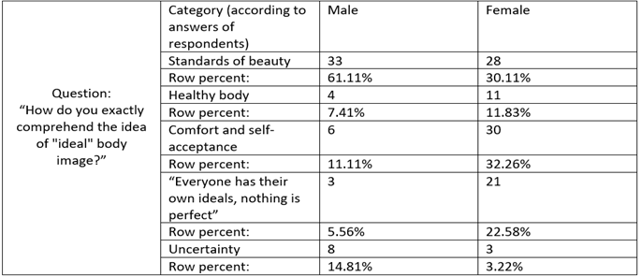
Cross tabulation 1.

Overall, 147 answers were collected from 150 respondents, and 54 answers were taken from males, while 93 answers were from females. The responses have given 5 categories from both genders. As it can be seen, there is a significant difference in quantities between men and women, however, the conclusion can be made. Most males comprehend the idea of “ideal” body image by the standards of beauty. It means they have an accurate image of the ideal body. For instance, the frequent reply to this question was “90-60-90”, which means the ideal proportion of a body. Moreover, the responses as “Slim and athletic body is the “ideal” body image” were common from males. Nevertheless, over 28 women answered the same as men. Another key moment is that 30 females understand the ideal body image as “comfort in your body and self-acceptance”, while only 4 of the males think the same. The similarities also can be seen in the category “Everyone has their own ideals, nothing is perfect”, which means that testees perceive this idea as individual by saying that every person has their own standards and ideals, and so nobody is perfect. Overall, over 11 people from both genders do not understand this idea. Regarding the interview, all of them answered as the most responders in the questionnaire - the standard of an ideal body image. To conclude, most of the males accept the idea of “ideal” body image by beauty norms, whereas women comprehend it by people accepting themselves and comfortable towards their body. Admittedly, the answers from the questionnaire were verified by the interview since there were similarities in responses.
- How people (teenagers and adults) react to this problem of “ideal body image” and cyberbullying in social media?
This research question was responded to as the same as the first one, which means by the help of interviews and questionnaire. In the questionnaire, the question “Some users are cyberbullying people with large body sizes. According to the diagram, most of the respondents are familiar with the “ideal” body image contest social media platforms (diagram 1). And consequently, the question “What is your reaction when you are facing this kind of situation?” had 4 categories assessing by answers of respondents: “Angry”, “It does not bother me”, “I will try to defend them” and “Other” (cross table 2). By this answer it can be identified as possible behavior tendencies of people towards the cyberbullying. Furthermore, for all people with variety age groups such problem is not profound since the row percent of “It does not bother me” had the highest index. This trend can be seen in the category “I will defend them”. The lowest outcome showed on section “Other”, where respondents have their own opinion such as “it bothers me, but it is very difficult to change the opinion of these cyber-bullies, so I keep quiet, another argument will not help anything” or “everyone expresses and will continue to express their opinions, even unsolicited ones”. The questionnaire was verified by the interview owing to 4 of them shared about negative feelings and opinion about this concern by feeling disgusted and angry. Also, one of the interviews mentioned about the hatred of the source of the bullying and defending the bullied side. To sum up, most of the teenagers and adults do not concern about cyberbullying on social media, however, the other half would show defense. In addition, most of the people would experience negative feelings. The significant apathy towards this problem from teenagers can lead to the growth of cyberbullying.
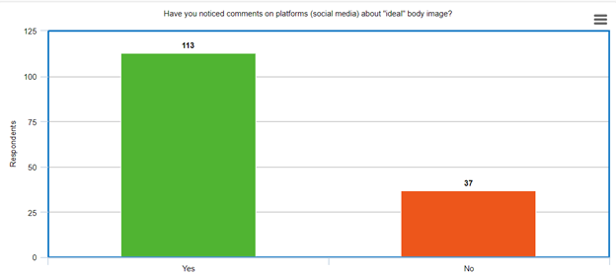
Diagram 8.

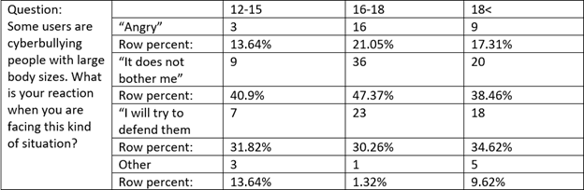
Cross table 2.
- What is the teenagers’ attitude towards the “ideal” body image? And what behavioral tendencies/trends of those who create the content about “ideal” body image, and those who watch them (users) can be seen in social media, namely TikTok and Instagram platforms?
This question was answered with the help of data analysis and interview. Data was analyzed by using two platforms: Tiktok and Instagram. Teenagers are divided by two opinions and views. First are the ones who support body positivity, and so they try to normalize the naturality of bodies. The second ones are those who are denying the idea of “natural beauty” from the first group, who are breeding this perception. The second group of teenagers tends to cyberbully, especially people with large size of body types. There are some observations, which are noticed during conducting this method. The list of behavior that was spotted: Consumption behavior, envious behavior, positive and negative approach (behavior), toxic behavioral patterns. In the TikTok app, most users showed envy and jealously in the comments by saying “if I only had that body...” or “I wish I were like that”. Also, there is a lot of videos of dieting or reversely, about fast food. It shows consumption behavior. Turning to toxic behavioral patterns, is related to cyberbullying, which was spotted in the comments, especially girls who are spreading the idea of body positivity. Many users are young people, which means the oldest generation does not usually use the TikTok app. While in the Instagram app is famous among all groups of age, not only young people but also the oldest people. Regarding cyberbullying, which represents toxic behavior, elders are also judging people for their appearance by adding “this person does not lead a healthy lifestyle”. This judgment can be upsetting since some teenagers do believe people, especially elders. This method was verified by interview since interviewees talked about cyberbullying, which illustrates toxic behavioral pattern. Also, 2 adults mentioned the behavior of “repeating trends”. For instance, the fashion can change every month, and so teenagers would try this trend. It can show consumption behavior since teenagers might buy special items for the specific trends.

Conclusion
The project aims to investigate the impact of everyday usage of Instagram and TikTok social media sites on body perception, as well as how people react to this problem of body dissatisfaction locally and internationally. The hypothesis is the role of body stereotypes in media dramatically raises teenagers' dissatisfaction and people ignoring this concern was confirmed. The following research questions were applied:
- How society (local people) understand the notion of “ideal” body image? How can they describe it?
According to P.D. Slade described body image is "the mental image we have in our mind, as well as our feelings about these characteristics”. Indeed, compared to the survey results showed most of the respondents had a common idea of the body. Turning to women’s ideas, they think it is all about comfort and self-acceptance, whereas men believe that the ideal body has slim and thin bodies in the questionnaire. Furthermore, the interview confirmed that older people tend to have this idea rather than youth. To conclude, most of the people in response to the standards of beauty have the same representation about the ideal body.
- How people (teenagers and adults) react to this problem of “ideal body image” and cyberbullying in social media?
As stated in the “Computers in Human Behavior” book, junior high school students are more likely to help victims of denigration and abuse than university students. Nevertheless, it is known by the primary research that most of the 16-18 years old students are unbothered about cyberbullying. Turning to adults, due to the lack of research on this topic, it is difficult to identify their exact reaction, however, research from “Psicología Educativa” speculates about the importance of parental involvement. Since there is a huge gap in ICT skills, adults do not understand the seriousness of this problem. In conclusion, most people are ignoring this serious issue.

- What is the teenagers’ attitude towards the “ideal” body image? And what behavioral tendencies/trends of those who create the content about “ideal” body image, and those who watch them (users) can be seen in social media, namely TikTok and Instagram platforms?
In the opinion of professors from Flinders University Adelaide, the frequently encountered behavior of teenagers was body surveillance, body damage, and depressive attitude. Admittedly, cyberbullying, which leads to toxic behavior is the main concern. The toxic behavioral patterns were noticed in the section on body positivity on TikTok and Instagram by observation. Comparing to the secondary research from Jana Holubcikova, they have a similar trend as body dissatisfaction has a strong association with cyberbullying. For example, people, who reject the idea of “natural beauty” cyberbully people of large sizes. Overall, in real life, teenagers face body damage together with depression but in social media, the common behavior is cyberbullying.
All the conclusions above can be generalized locally and globally, since sample of this research was city dwellers of Oskemen and analyzing behavior of teenagers worldwide in TikTok and Intsagram. The results on the body dissatisfaction and cyberbullying can be used to take actions to solve the issue related to them. Also, school and university administrations can make some events by helping youth to cope with stressors (social media etc.).

Evaluation
All research questions were answered to get precise information and the conclusion.
Firstly, the target group of the survey was successfully chosen since it helped to create a cross table of reliable and variable information. Furthermore, the significant advantage is that respondents tried to give a complete answer in open-ended questions. It assisted to answer two research questions. However, some questions were not necessary for the research questions. Instead, it would be better to delete redundant questions to reduce the quantity of them. For instance, the question "Do you think the main problem of low self-esteem is the “ideal” look in social media? Why?" did not assist in answering research questions since that it was not related.
The second method was the interview, which was beneficial in detailed responses. The interview questions included questions from the survey to confirm the first method. 2 interviewees were teenagers, and the other two were adults. It helped to notice dissimilarities in their opinions as teenagers tend to support “natural beauty” more rather than adults. Nevertheless, to get a more accurate conclusion (to see clear differences in views), there should have been more interviewees since 4 people were not enough.
The third method is data analysis, which represented common behavioral patterns in social media among teenagers. It helped to analyze data as to how teenagers perceive the “ideal” body image, and how people react to the content related to the body in TikTok and Instagram platforms. The hardest part of this method was to analyze all the comments and capture adequate users` opinions. Since some users use a lot of curses or incomprehensible phrases. It will be much effective to gather some people to monitor their reaction and to observe the comment section. As it is an easier and more organized way to analyze data.

Further research
Below are the steps that could be taken to improve and extend the research:
- A much larger sample group with teenagers and adults, especially ages 12-15 and older than 25 years old, and interview methods would make the results much more precise. Since the research dedicated to people’s perception of a body (people of different age groups), and so their opinions matter. Furthermore, also responses of people in different regions should be taken. Since, it could assist in more extensive research.
- Document analysis could be used as another method. Observation or focus group discussion could give more practical knowledge related to the body rather than theoretical. It also could give unexpected results since research could be specialized in monitoring the behavior of participants (their behavior can be changed because they know they were watched).
- The research can be improved by doing social experiments. For instance, participants can be citizens, and they could share their opinions by writing their age and gender on paper and put it in the special box. It also could give more additional practical experience and data. It would enhance the conclusion since it could make it more accurate.
- The interview method should be improved by taking more interviewees. The sample group is teenagers and adults and therefore there should be more interviewees from 12 to 40 years old. Moreover, face-to-face interaction is an essential part of the interview, and so the behavior could be observed. It would aid in the creation of a more accurate result. Nevertheless, owing to the pandemic, real-life interviews could not be conducted.
Admittedly, my personal perspective throughout this research project changed. Since I discovered people’s behavior, which helped me to comprehend psychology even more. Also, knowing the exact stressors of teenagers’ body dissatisfaction assists in coping with them. The further aim can be the possible solutions of body-damage and dissatisfaction among youth. The possible subtopic could be not only cyberbullying, but also bullying in real life.

Bibliography:
- Invited essay “What is body image?” (May 24, 2002) Retrieved from: https://www.sciencedirect.com/science/article/abs/pii/0005796794901368
- “Net Girls: The Internet, Facebook, and body image concern in adolescent girls” (September 5, 2013) Retrieved from: https://journals.sagepub.com/doi/10.1177/0272431613501083
- “Body image, perceived pubertal timing, and adolescent mental health” (July 16, 1999) Retrieved form: https://www.sciencedirect.com/science/article/abs/pii/S1054139X98001608
- “Is subjective perception of negative body image among adolescents associated with bullying?” (February 24, 2015) Retrieved from: https://link.springer.com/article/10.1007/s00431-015-2507-7
- “How students react to different cyberbullying events: Past experience, judgment, perceived seriousness, helping behaviour and the effect of online disinhibition” (March 9, 2020) Retrieved from: https://www.sciencedirect.com/science/article/abs/pii/S0747563220300923

- “The emergence of cyberbullying in childhood: Parent and teacher perspectives” (March 22, 2016) Retrieved from: https://www.sciencedirect.com/science/article/pii/S1135755X16000117
- “Riverdale star Lili Reinhart's 'powerful' body image speech” (November 12, 2018)
Retrieved from: https://www.bbc.com/news/newsbeat-46177070
- ” Millions of teenagers worry about body image and identify social media as a key cause – new survey by the Mental Health Foundation” (May 13, 2019) Retrieved from: https://www.mentalhealth.org.uk/news/millions-teenagers-worry-about-body-image-and-identify-social-media-key-cause-new-survey
- “Body image and social media: cross-cultural comparison between Kazakhstan and USA” (2018) Retrieved from: https://pureportal.strath.ac.uk/en/publications/body-image-and-social-media-cross-cultural-comparison-between-kaz

Appendices:
Appendices-1
Survey
Title: “Ideal body” image
The aim of this survey was to see the relevance of the issue and possible effects of “ideal” body image and the reaction of people to cyberbullying. Furthermore, to give the conclusion of how people comprehend idea of “ideal” body image.
As a part of my research work, I am conducting a research survey about “ideal” body image and the effects that social media have on the perception of a body. I believe that body dissatisfaction perhaps is caused by social media influence, namely because of the people who are judging by their appearance in comments. Thereby, knowing the reasons for body dissatisfaction, which might lead to severe consequences as body-damage, will help spread awareness to help people feel content and free towards their body. Therefore, I would like to use this survey for my research project. Remember that survey is anonymous.
- Your age? / Ваш возраст?
- Your Gender? / Ваш пол?
- Have you ever encountered a problem with the self-perception of a body? / Вы когда-нибудь сталкивались с проблемой самовосприятие тела?
- Are you happy with the way you look? / Вы довольны тем, как выглядите?
- Have people’s opinions about your body bothered you? Do you feel insecure or offended then? / Мнение людей о вашем теле беспокоит вас? Вы чувствуете себя неуверенно или обижены?
- Do you use Tiktok and Instagram platforms daily? / Используете ли вы платформы Тикток и Инстаграм ежедневно?
- How do you exactly comprehend the idea of "ideal" body image? / /Как именно вы понимаете идею "идеального" образа тела?
- Have you noticed comments on platforms (social media) about "ideal" body image? / Замечали вы комментарии на платформах (социальных сетях) об "идеальном" имидже тела?
- Some users are cyberbullying people with large body sizes. What is your reaction when you are facing this kind of situation? / Некоторые пользователи социальных сетей занимаются кибербуллингом (осуждение и издевательство в социальных сетях) с людьми, имеющих большие размеры тела. Какова ваша реакция, когда вы сталкиваетесь с подобной ситуацией?
- Do you think the main problem of low self-esteem is the “ideal” look in social media? Why? / Считаете ли Вы, что основная проблема низкой самооценки - "идеальный" вид в социальных сетях? Почему?
Diagrams:
Question 1: 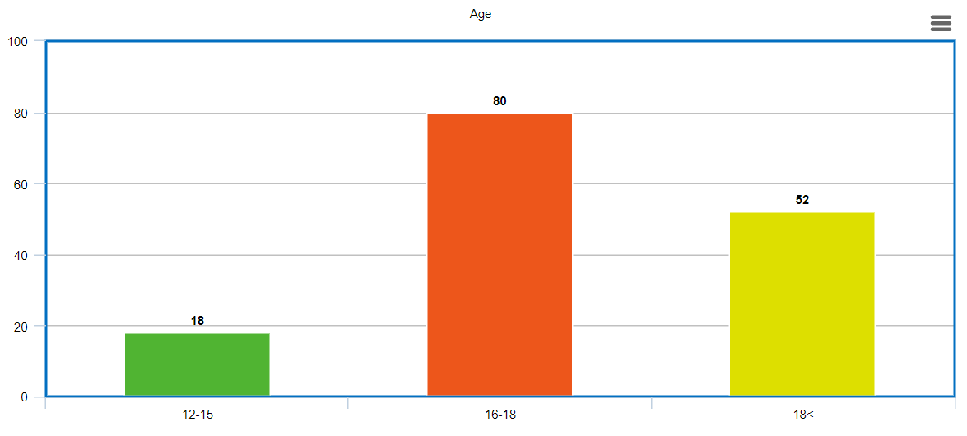
Diagram 1.

Question 2:
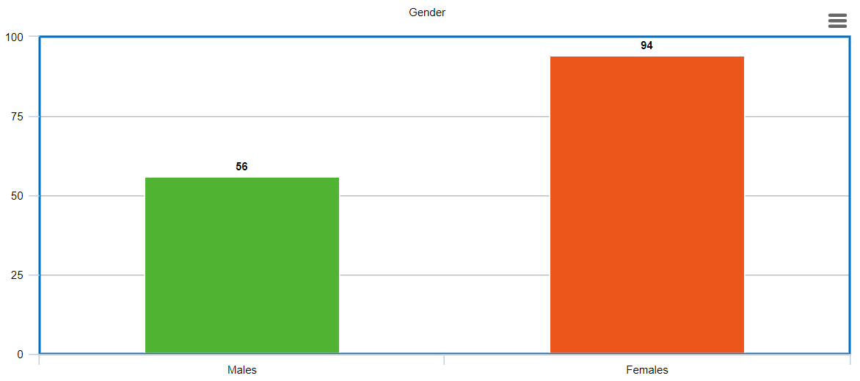
Diagram 2.
Question 3:
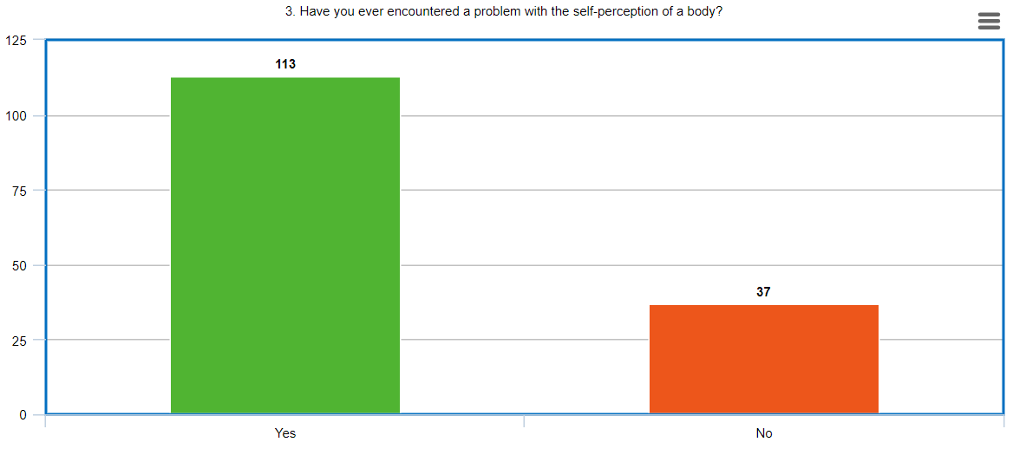Diagram 3.

Question 4:
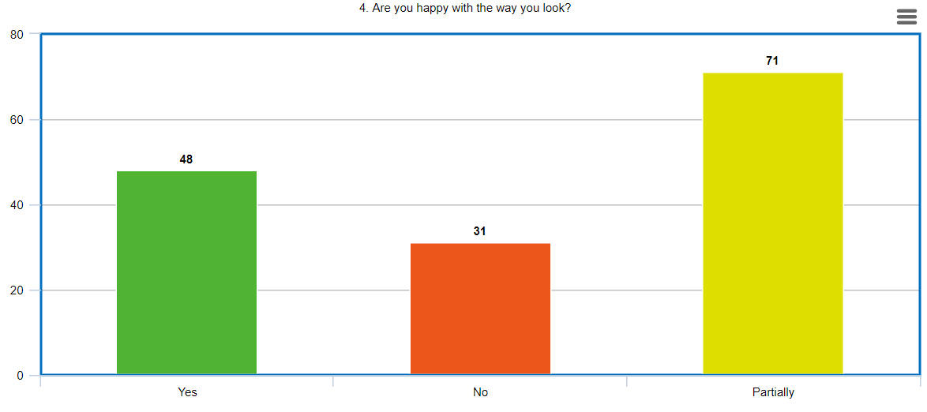
Diagram 4.
Question 5:
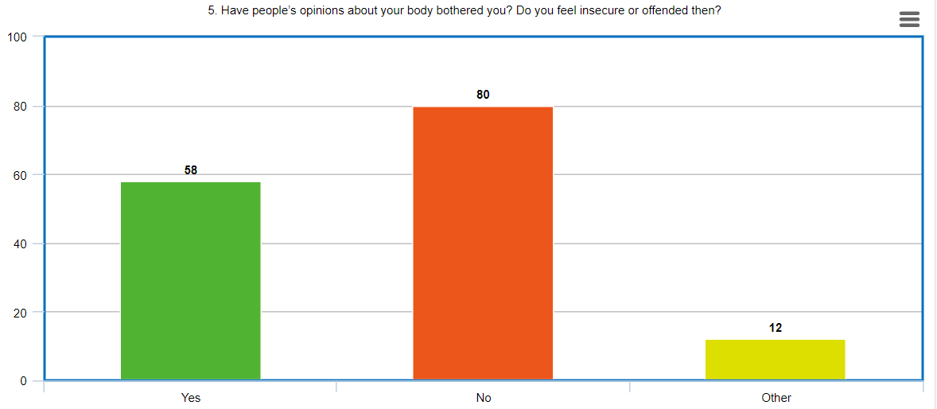
Diagram 5.

Question 6:
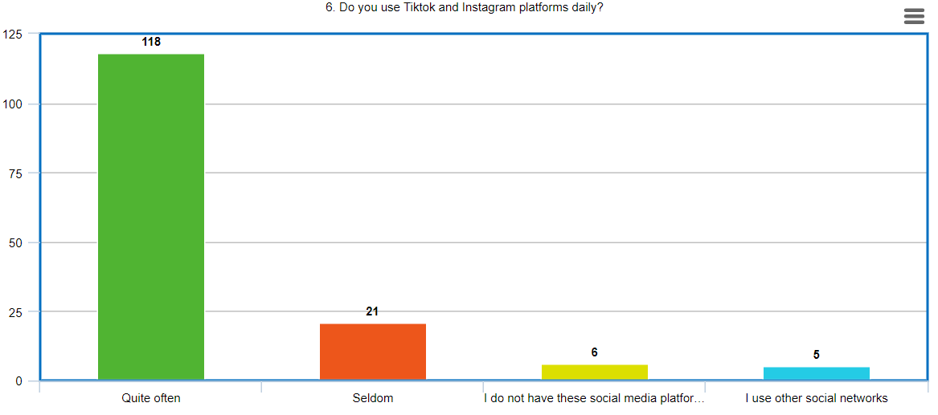
Diagram 6.
Question 8:
Diagram 8.

Question 9:
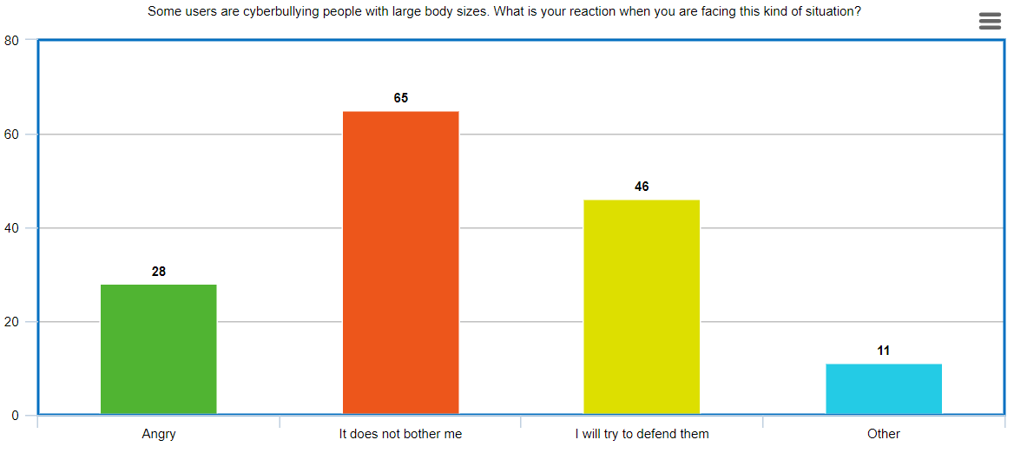
Question 9.

Appendices-2
Interview
Title: Comparison between teenagers and adults in comprehending “ideal” body image.
The aim of the interview was to verify the answers of questionnaire, and to have more detailed information about interviewees’ perception of a body.
- Questions: Are you completely happy with the way you look? If not, why? /Вы полностью довольны тем, как вы выглядите? Если нет, то почему?
- Do you usually encounter the “ideal” thin bodies in social media, especially TikTok and Instagram platforms? What do you think about it? /Сталкиваетесь ли вы обычно с идеей “идеальные тела”, особенно в платформах TikTok и Instagram? Что вы об этом думаете?
- How can the “ideal” body image influence teenagers` appearances? Could you give some examples from your life/experience? /Как "идеальный" образ тела может повлиять на внешность подростков? Не могли бы вы привести несколько примеров из вашей жизни/опыта?
- Is there a specific definition of a “perfect body” in social media? How can you describe it? (the idea from Jarrah Bowley, “Interview - Body image and Self-esteem”, 2015)/Существует ли конкретное определение "идеального" тела в социальных медиа? Как вы можете его описать?
- Can you tell me the effects of such a tendency that TikTok and Instagram have towards teenagers nowadays? Have you noticed the changes in their behavior generally? Could you give some examples? /Можете ли вы рассказать о влиянии такой тенденции, которую TikTok и Instagram имеют на подростков в настоящее время? Заметили ли вы изменения в их поведении в целом? Не могли бы вы привести несколько примеров?
- Some people (users) bullying people in social media owning to their sizes or unique appearance. It is a part of cyberbullying on the internet. Can you describe your reaction in detail to seeing such behavior? /Некоторые люди (пользователи) издеваются над людьми в социальных сетях, руководствуясь их размерами или уникальным внешним видом. Это часть кибер-буллинга в интернете. Можете ли вы подробно описать свою реакцию на такое поведение?
- Do you have friends or acquaintances who have low self-esteem due to their bodies? If yes, how do you support their mental condition? /Есть ли у вас друзья или знакомые, которые имеют низкую самооценку из-за своего тела? Если да, то как вы поддерживаете их психическое состояние?
- Do you support the idea of “ideal” body image? Why/Why not? /Поддерживаете ли вы идею "идеального" образа тела? Почему? /Почему нет?
- How can people spread awareness about this issue in your opinion? (Interviewee suggests some ways)/Как, по вашему мнению, люди могут распространять информацию по этому вопросу?
Appendices – 3
Data analysis
Key features:
- People, who support body positivity: https://vm.tiktok.com/ZSJybn2ta/ https://vm.tiktok.com/ZSJygL2Wq/
https://www.instagram.com/p/COyHUx7g42z/?igshid=nf89l
- Toxic behavior: https://vm.tiktok.com/ZSJygetuv/
- Envy and jealous: https://vm.tiktok.com/ZSJybnqjf/
- Consumerism: https://vm.tiktok.com/ZSJybce75/
- Mixed (envy and toxic): https://www.instagram.com/p/CNStdbsjd43/?igshid=d8pooa8n5igg

