УДК Mukhamadiyev D.R. (Karaganda, KSU)
697.942

ASPIRATION SYSTEM: PURPOSE, TYPES, AND KEY ELEMENTS

Abstract
The increased dust content of the air at industrial enterprises is a negative factor that affects the health of workers. To solve this problem, it is necessary to install dedusting systems, in another way, aspiration systems, in production. It is especially important to use these systems in industrial plants with high dust emission. This article examines the purpose and necessity of installing aspiration systems in production. Describes such types of aspiration system, as monoblock and modular, and their difference. The greatest attention is paid to the consideration of the types of equipment for air purification: cyclone dust collectors, gravity filters, dust collectors, bag filters, dust collectors. The main aspects of design, installation and installation of aspiration systems are briefly covered.

Key words: aspiration system, cyclones dust collector, gravity filter-dust collectors, baghouse filters-dust collectors, monoblock and modular ventilation systems.

Аннотация
Өнеркәсіптік кәсіпорындардағы ауаның шаңдануы қызметкерлердің денсаулығына әсер ететін теріс фактор болып табылады. Бұл мәселені шешу үшін өндірісте шаңсыздандыру жүйелерін (аспирациялық жүйелерін) орнату қажет. Бұл жүйелерді үлкен шаң шығаратын өнеркәсіптік кәсіпорындарда қолдану өте маңызды. Бұл мақала өндірісте аспирациялық жүйелерді орнатудың мақсаты мен қажеттілігін қарастырады. Аспирациялық жүйенің моноблокты және модульді түрлері және олардың айырмашылығы сипатталады. Ауаны тазартуға арналған жабдықтардың түрлерін қарастыруға көп көңіл бөлінеді: циклонды шаңтұтқыштар, гравитациялық сүзгі-шаңтұтқыштар, жеңдік сүзгі-шаңтұтқыштар. Аспирациялық жүйелерді жобалаудың, монтаждаудың және орнатудың негізгі аспектілері қысқаша қамтылады.

Түйінді сөздер: аспирациялық жүйе, циклонды шаңтұтқыштар, гравитациялық сүзгі-шаңтұтқыштар, жеңдік сүзгі-шаңтұтқыштар, моноблокты және модульдік желдету жүйелері.

Аннотация
Повышенная запыленность воздуха на промышленных предприятиях является отрицательным фактором, сказывающимся на здоровье рабочего персонала. Для решения данной проблемы необходима установка обеспыливающих систем, по-другому аспирационных систем, на производстве. Особенно важно применение данных систем на промышленных предприятиях с большим пылевыделением. Данная статья рассматривает цель и необходимость установки аспирационных систем на производстве. Описываются такие типы аспирационной системы, как моноблочная и модульная, и их разница. Наибольшее внимание уделено рассмотрению видов оборудования для очистки воздуха: циклонные пылеуловители, гравитационные фильтры-пылеуловители, рукавные фильтры-пылеуловители. Коротко освещаются основные аспекты проектирования, монтажа и установки аспирационных систем.

Ключевые слова: аспирационная система, циклонный пылеуловитель, гравитационный фильтр-пылеуловитель, рукавные фильтры-пылеуловители, моноблочные и модульные системы вентиляции.

The increased dustiness of the air is one of the main harmful and dangerous production factors for many industrial enterprises. To eliminate the negative impact of dust on the health of personnel, as well as to improve technological processes, the facility must be equipped with an aspiration system. The aspiration system removes dust from the air and brings its quality indicators in line with regulatory requirements.
Aspiration is the process of removing dust, fibers, fog, and other suspended matter from indoor air. It should be carried out at the production facilities of enterprises in such industries as woodworking, pulp and paper industry, mining, metalworking, and other areas of production, which are characterized by increased dust emission during technological processes.
Installation of air aspiration systems is provided for industrial premises with intensive dust emission. At such facilities, local exhaust ventilation is not enough to quickly remove contaminated air and fully purify it.
Unfortunately, in most industries, the existing aspiration and ventilation systems often do not fulfill their purpose. This is mainly caused by the deterioration of the existing aspiration and technological equipment or the connection of new dusting points during the expansion of production to the existing aspiration system, which is not designed to increase the load.
Problems arising from here:
• the concentration of harmful substances in the air emitted into the atmosphere does not meet the standards, which leads to penalties and additional checks by regulatory authorities.
• dust content in production halls increases.
• accelerated wear of technological equipment occurs and there is a risk of downtime.
• production costs for service and consumables are growing.
Sources of dust intake are the places where bulk materials are fed into the technological equipment and the places where such materials are removed. The successful design of the local suction, the correct calculation of the air duct network and the aerodynamic resistance of the aspiration system, the correct selection of a high-pressure fan and competent automation of the aspiration systems allow reducing the dust content of the process to the maximum permissible level with lower air consumption.
Purification of a gas-dust mixture is based on air filtration, the purpose of which is to bring the level of concentration of harmful substances in the air emitted into the atmosphere to the maximum permissible emission in accordance with the norms of state sanitary supervision. The filter is chosen depending on the required degree of air purification; the size of the dust particles; dust properties (dry, fibrous, sticky, hygroscopic, etc.); initial dust content; temperature of the cleaned air.
The aspiration system provides air intake directly in the polluted area by creating a significant vacuum and filtering it with subsequent discharge into the atmosphere or returning to the room. Removal of contaminated air masses is provided through separate air ducts, which are laid with a significant angle of inclination. This method of installation prevents the formation of stagnant zones in which contamination could accumulate.
The aspiration unit includes an air intake device (local suction), a fan in the aspiration system, filtration equipment that separates contaminants from the air, and a waste accumulator.
The dust extraction system works in close integration with the ventilation system. The fresh air supply must provide sufficient fresh air to replace the volume of contaminated air to be removed.
Depending on the design, the aspiration ventilation systems are divided into two types: monoblock and modular. Monoblock aspiration unit integrates all system components and is completed at the factory. The equipment is supplied with the specified characteristics, therefore, to equip a specific object, it is necessary to select a model with suitable characteristics. Usually, monoblocks are small aspiration units designed to service production facilities with a relatively small amount of dust emission.
A modular aspiration system is designed specifically for a specific object, considering its individual parameters. This achieves a high level of efficiency of the aspiration system. It corresponds to the production facility where it is installed and provides high-quality cleaning without wasting energy. This type of aspiration systems is suitable for medium and large industrial enterprises, for which the use of monoblocks is impractical.
In addition, air aspiration systems are classified according to the pressure developed by the fan into low-pressure (pressure level up to 7.5 kPa), medium-pressure (pressure in the range from 7.5 kPa to 30 kPa), high-pressure (pressure more than 30 kPa).
The key elements of the aspiration system device include equipment for cleaning the discharged air masses from dust. It must provide a sufficient degree of air purification from polluting components typical for this production facility. The characteristics of these devices determine the compliance of the aspiration system with environmental standards, as well as the possibility of using a closed cycle with the return of purified air to the room.
The most common types of air purification equipment are cyclones dust collector, gravity filter-dust collectors, baghouse filters-dust collectors.
Figure 1. The cyclone dust collector
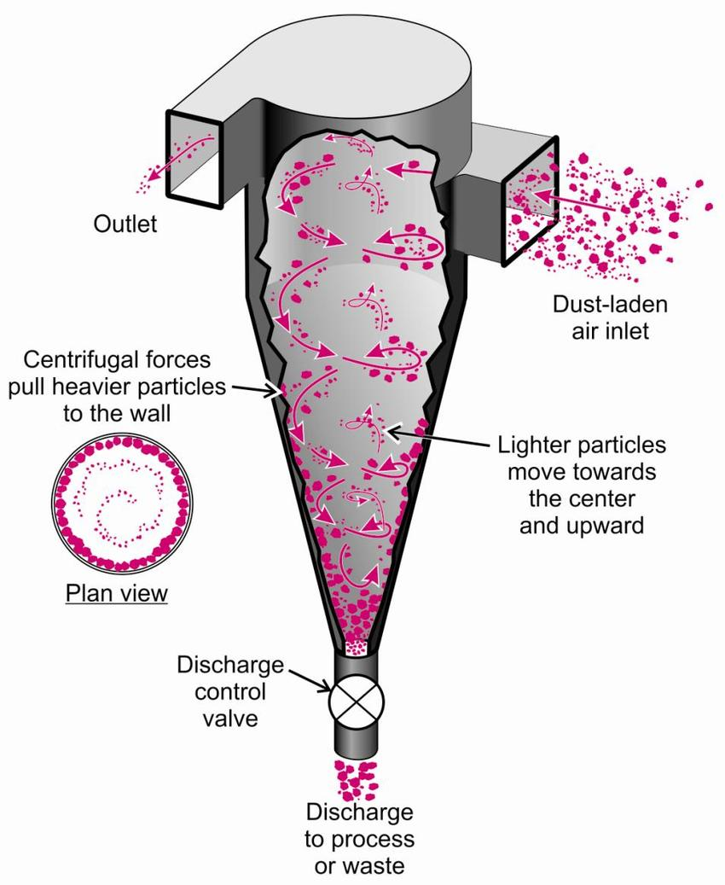

The cyclone dust collector is the oldest and most common type of air purification device. Air is supplied to the cyclone by a fan and, passing through the installation (Figure 1), swirls into vortex flows around the axis of the apparatus. As a result of the action of centrifugal forces, particles of pollutants, which are heavier than air, settle on the walls of the cyclone and are further sent to the dust collector under the action of the secondary flow. These devices have a sufficient degree of cleaning efficiency. They are reliable, unpretentious, and easy to maintain.
The cyclone dust collector provides cleaning of air masses from dust of various composition and other solid suspensions of fraction from 5 microns. If fine dust is present in the air, then such a device will not be able to provide sufficiently effective cleaning. The disadvantage of the cyclone is the high level of aerodynamic resistance, which increases the required fan power.
The gravity filter-dust collectors provide for the deposition of dust from air streams that pass in the body of the apparatus in a horizontal direction. Sedimentation occurs by gravity of the dirt particles that accumulate in the silo. The internal chamber of the machine is often divided into several compartments, which increases the cleaning efficiency. The gravity filter-dust collectors clean the air only from coarse dust particles. In addition, there are limitations on the composition of the contaminants, since only sufficiently heavy particles can settle. Filters of this type are characterized by low efficiency, so they are often used for coarse primary air purification.

Figure 2. The gravity filter-dust collector
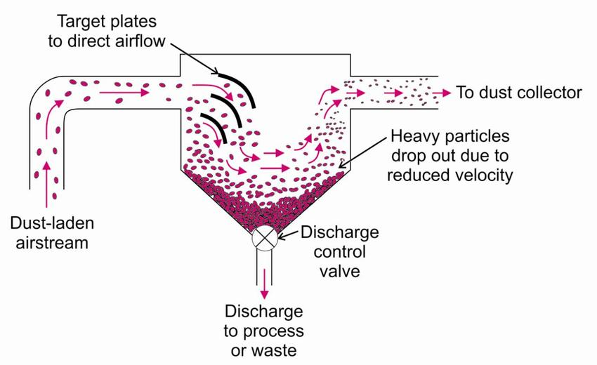

Figure 3. The baghouse filters-dust
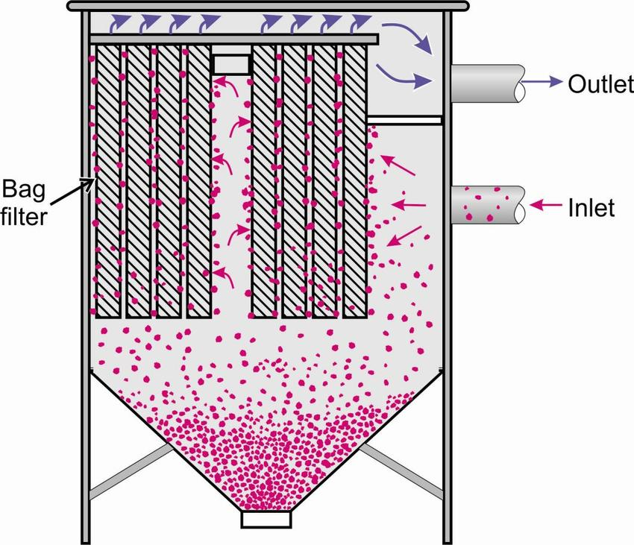

The baghouse filters-dust collector is equipment for high performance aspiration system. It allows purifying significant volumes of air per unit of time. Moreover, such devices cope with the separation of contaminants of very different composition.
Contaminated air is supplied through channels located in the body of the device. Cleaning sleeves made of special fabric or non-woven material are laid inside the channels, which function as cleaning elements. Air passes through the material of the bag, and particles of dust and other pollutants are trapped in it. The hoses are periodically cleaned using special methods, because of which the dust settles in the hopper. Due to this, the throughput of the equipment is restored.
The baghouse filters-dust collectors are classified as "dry" type dust collectors and can be used in almost all industrial processes that emit dust. Compared to wet cleaning devices, bag filters have a higher efficiency and do not require constant maintenance, they can work continuously using a filter element regeneration system.
The cleaning efficiency of baghouse filters can be up to 99.9% even with the most difficult contaminants, including fines, sticky, and wet contaminants. On the other hand, these are the most expensive and difficult-to-maintain devices.
The efficiency of the air aspiration system in production depends on professional design. The important parameters taken into account in the design include the amount of pollutants emitted into the air and the composition of pollutants, the required air exchange, the characteristics of the existing or projected ventilation system, temperature and other conditions in the production room.
Based on the data obtained, the required performance of the main elements of the system is calculated. For example, when calculating the power of the fan, the pressure losses in the air duct network must be included. Their value can be from 15 to 30%, depending on the length, type of air ducts, network configuration, as well as on the quality of sealing during installation. Calculating fan performance without considering head losses is a common mistake. It leads to the fact that the capacity of the installed system turns out to be insufficient for full-fledged diversion.
When designing aspiration systems, there are some features:
• all sources of dust and gas emission are provided with local suction.
• the aspiration system should not block access to technological equipment.
• before being discharged into the atmosphere, the air must be cleaned in special filters.
If the aspiration systems are well designed, it is possible to recirculate the purified air - returning it back to the room through an additional cleaning stage and air diffusers, thus eliminating the need for a compensating supply system.
The economic effect of such a solution is obvious: the cost of equipment for such a system, work on its installation, operation is 5-10 times lower than the cost of the supply system, and there is no need to heat the supply air.
At the design stage, a diagram of the aspiration air ducts is being developed. The optimal route of their laying is determined, the angle of inclination, the type of air intake devices used and their placement on the object are calculated.
After the approval of the developed project of the aspiration system, the selection and delivery of equipment and components for its installation is carried out. The equipment is installed on site in accordance with the layout diagram.
In conclusion, the presence of an aspiration system in industrial enterprises with high dust emission is a prerequisite for a competent organization of the work process. An efficient aspiration system in the workplace maintains working conditions that meet regulatory requirements, which has the effect of reducing occupational morbidity and accidents. Aspiration increases the level of fire and explosion safety of many production facilities. In addition, it creates conditions for the normal course of technological processes and the reduction of harmful emissions into the atmosphere.

References

Ghorbani F., Bahrami A., Farasati F. 2012. "Application of Local Exhaust Ventilation System and Integrated Collectors for Control of Air Pollutants in Mining Company", Industrial Health, Hamedan University of Medical Science, Iran, 450–457.

Xie B., Li S., Jin H. 2018. “Analysis of the performance of a novel dust collector combining cyclone separator and cartridge filter”, Powder Technology, China University of Mining and Technology, China, 695-701.

Dedyulin A. 2019. " Aspiration systems: types, device, installation selection criteria", Retrieved from: https://sovet-ingenera.com/vent/raschety/aspiracionnye-sistemy.html

